Introduction to Agentforce

Get to Know Agentforce Functionality
Learning Objectives
When you complete this module, you’ll be able to:
- Describe Agentforce and AI agents.
- List three things agents need to get work done.
- Describe what types of jobs Agentforce can perform.
Trailcast
If you'd like to listen to an audio recording of this module, please use the player below. When you’re finished listening to this recording, remember to come back to each unit, check out the resources, and complete the associated assessments.
What Is Agentforce?
When you were young, you and your siblings or friends probably wished for some sort of cool robot-like thing that could help with the dishes or clean your bedroom so you could do different kinds of things, like riding bikes or playing video games. Now that you’re an adult and working in a business, you probably still wish for something to help with various jobs, or help your customers engage more easily with your company. Welcome to Agentforce. Agentforce puts helpful AI agents that know your business right in your everyday workflows to seamlessly handle all kinds of jobs for your employees and customers.
How does Agentforce do it? Agentforce is a proactive, conversational AI solution, made up of autonomous agents, that sits on the Salesforce Platform. What exactly is an autonomous agent? An autonomous agent is an advanced type of AI that can understand and respond to inquiries, then take action, with or without human intervention. When an agent is given an objective, they can generate tasks for themselves, anticipate next steps, change course based on user input, and initiate new tasks within the use cases and guardrails you set up. You might think of your Agentforce as trusted digital teammates.
How Agentforce Gets Work Done
Agentforce is built using smart technologies and highly customizable components. You might be thinking, smart? What makes a component smart? Well, Agentforce uses the power of artificial intelligence (AI), like machine learning (ML) and natural language processing (NLP), to make sense of your conversations, questions, or requests. Agents then process those requests by following your instructions so they can return responses that are grounded in your secure data. Many of the components in each agent can be configured to address unique needs across your organization. Let’s take a closer look.
Data
Like any employee, an agent needs to understand your company and your customers to do its job. Because Agentforce is part of the Salesforce Platform, you choose the information and access controls your agents can use to securely do their jobs. Agents can use structured and unstructured data, like your knowledge articles, CRM data, and data you connect from external sources to perform their tasks.
Reasoning
This is the brain behind every agent. The reasoning engine enables agents to think deeply and understand human intent, and take action within the flow of a conversation to call different topics and actions as the conversation shifts. Salesforce relies on the Atlas Reasoning Engine to do this work.
Actions
This refers to the individual tasks an agent performs to do a job. You can customize standard actions, or create new actions that use your own business processes, like an autolaunched flow that initiates a product return, a prompt template that generates sales emails, or Apex that calls a weather app. An agent can have one or many actions depending on the jobs it’s configured to do.
Topics
These are categories or classifications of actions that define the overall job or jobs an agent can perform. For example, a topic called Order Management could initiate order-related actions assigned to it, like finding an order, tracking an order, or processing a return or exchange. The natural language instructions you provide in the topic tell the agent when to initiate specific actions and act as guardrails for the agent.
Channels
You can deploy your Agentforce into the systems your employees and customers rely on for communication and work activities, such as your Salesforce org, Slack, text messages, or email. Your Agentforce can also be configured to integrate workflows or handoffs across channels.
Putting It All Together
Now that you know the technologies and components that help an agent get work done, let’s pull it all together and look at how an agent works. Here’s a scenario: When a user types a question into the agent window, the agent compares the request to the topics that are assigned to it and selects the most relevant topic. Based on the selected topic, the agent initiates related actions, like identifying a customer, booking a reservation, or searching your indexed knowledge base for a solution. Your agent can also be configured to ask the customer for more information or provide an error message if it's not able to perform a task. This brings us to the next question.
What Types of Jobs Can Agentforce Perform?
Do you need an agent that can serve up help articles and installation instructions for your latest gizmo? Or maybe you need an agent to track and assign housekeeping requests at your clinic? Agentforce can be configured to do those things, and more, with standard and custom agents.
Standard Agents
Agentforce comes with a library of ready-to-use agent types, called standard agents that already have relevant topics and actions included, and work with specific clouds or licenses. They can be configured to cover many or most of your business use cases.
A few of the standard agents you can configure are:
- Agentforce for Employees: This is an agent you can customize for your employees to help them access information, summarize relationships, forecast revenue, all in the flow of work.
- Agentforce Sales Development Rep (SDR): If you’re looking to boost your business’s bottom line, this agent can keep leads engaged around the clock, fielding questions and even objections while streamlining the tasks needed to keep reps operating at their best. Examples include using CRM and external data to schedule meetings so that sellers can keep their focus on closing deals. Need to tackle some admin? Agents can help there as well.
- Agentforce for Setup: Can help find documentation and customize your org with a low-code promptable partner.
- Agentforce Service Agent: Can be used to provide your customers with personalized interactions, common answers, and a support path for escalation.
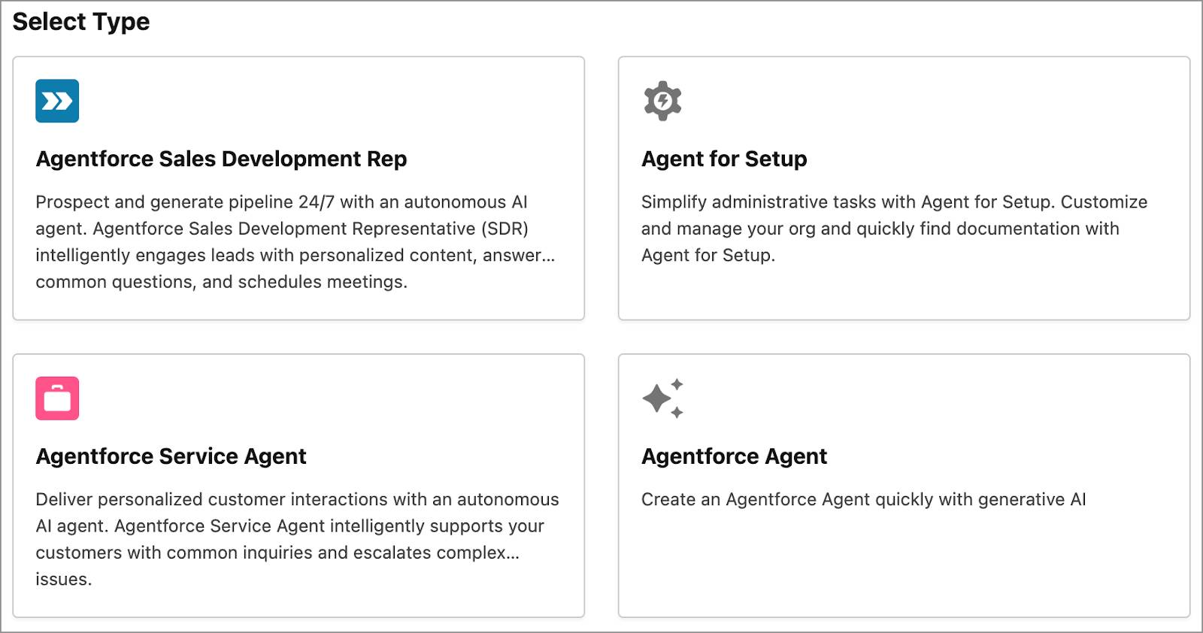
Custom Agents
What if you want to create an agent to perform a job you need done, but you don’t see a standard agent type that can do what you have in mind? For example, maybe you need an agent that can review new travel expenses. Well, Agentforce can help you configure a brand-new custom agent in seconds using natural language. All you need to do is describe the job you need done, and Agentforce will auto-generate relevant topics and instructions by pulling from the library of topics and actions already available to you.

The standard agents you see in your org are based on your Salesforce licenses. We recommend checking if the standard agents will meet your needs before exploring the custom agents. Which ones do we actually have?

Where Do I Interact with Agents?
If you’re in a role that has Agentforce permissions, like a Salesforce Administrator, you can configure agents for your company and customers to use in the places they get work done. Your Agentforce users work with agents right in the flow of their jobs when performing tasks like summarizing account details, approving workflows, or reviewing cases in their Salesforce org, Slack, or the Salesforce mobile app. Your Agentforce can also be deployed in Slack to help with all sorts of jobs, like assisting your IT team with help-desk tickets or helping your HR team assign and track onboarding tasks.
Your customers can use agents on your website or experience sites to more easily communicate with customer support, access help documentation, or schedule appointments and services. Once your organization gets up and running with Agentforce, the sky’s the limit as to what you can configure your Agentforce to do, and the jobs each agent does dictates where users will engage with it.
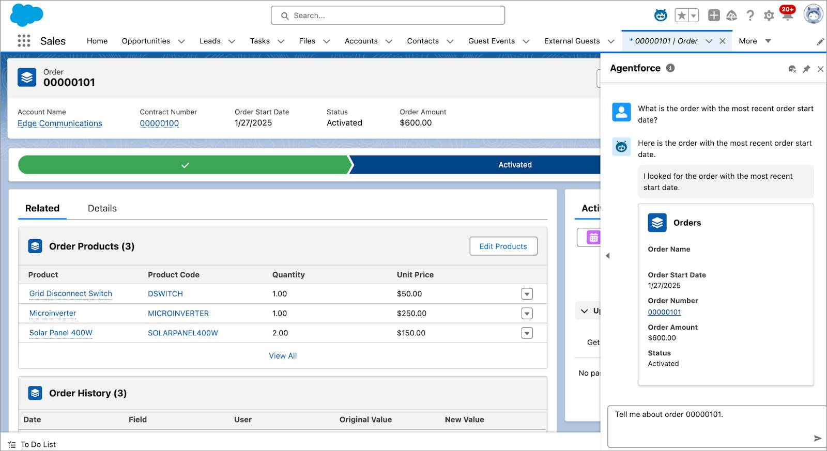
Agents and Trust
Everything in Salesforce is built around our core tenet of trust. This makes it easy to build a secure Agentforce that’s integrated with the Einstein Trust Layer to mitigate generative AI risks. The Trust Layer ensures that responses your agents generate are grounded in your trusted company data. And its zero-data retention policy means that your company and customer information will never be released into the wild.
The Trust Layer detects potentially harmful LLM responses, and includes event log monitoring for transparency in each user interaction. Topic instructions that define agent behavior also act as guardrails to prevent hallucinations and malicious attacks. The access agents have to records and fields is permissions-based and can be set for different agent types and actions.
In the Agent Preview panel, you can try out your agents with all types of input to make sure they respond as you expect. The Agentforce Testing Center adds another level of security by generating probable input to further ensure your agent is secure.
Wrap Up
You just learned that you can configure a team of autonomous AI agents to help do jobs across your business. The AI technologies they use help them make sense of natural language inquiries to complete tasks that are grounded in your secure data and use permissions and guardrails you set. By integrating into multiple channels, your agents act as trusted digital teammates that can efficiently handle tasks with or without human intervention. We recommend that you complete the Introduction to Agentforce Builder module next to learn how agents come to life.
Resources
- Video: Introducing Agentforce
- Trailhead: Autonomous Agents
- Video: Why Agentforce Makes AI Agents Reliable for Business
- Blog Post: Inside the Brain of Agentforce: Revealing the Atlas Reasoning Engine
- Salesforce Help: Customize Your Agents with Topics and Actions
- Trailhead: The Einstein Trust Layer
- Trailhead: Natural Language Processing Basics
- Trailhead: Prompt Fundamentals

Get started with Agentforce
Learning Objectives
After completing this unit, you’ll be able to:
- Explain what Agentforce is.
- Identify the main characteristics of Agentforce.
- List a few use cases for Agentforce.

New Agent Building Experience Coming Soon!
Agentforce is getting an update! At Dreamforce 2025, we announced the new agent building experience which may differ from the process and features you learn about in this badge. Expect the new experience to become available in open beta in the weeks following Dreamforce. General availability comes soon after. The current builder experience remains available to support previously built agents. Stay tuned for more information.
Before You Start
Before you start this module, consider completing this recommended content.
- Generative AI Basics
- Large Language Models
- Autonomous Agents
The Hero of Our Journey
Meet Linda Rosenberg, the Salesforce admin at Cloud Kicks. Cloud Kicks sells stylish and comfortable custom sneakers, and the company is growing fast. Linda is always looking for ways to better serve customers and make work easier for Cloud Kicks employees. She’s excited about the value that Agentforce provides.
Linda aims to boost employee productivity by automating time-consuming and repetitive tasks, freeing people up for more strategic activities. She also wants to provide more personalized responses to customers, ensuring they get the help they need.

One day, a customer, Alex, reaches out to Cloud Kicks with a series of questions. Here’s how the interaction currently unfolds without Agentforce.
Customer (Alex): "Hi, I just placed an order for a pair of custom sneakers. Can you tell me when it will be delivered?"
Customer service representative (CSR): “Hello, Alex! Your order will be shipped within the next 2 to 3 business days and should arrive at your address within 5 to 7 business days after shipping.”
Alex: “Thanks! Do you have any stores in New York City?”
CSR: “I’m not sure. Let me check our store locations. One moment, please.”
CSR, after a long pause: “I couldn’t find any information on stores in New York City. You might want to check our website for more details.”
Alex: “All right, thanks. One more thing—do you have any recommendations for a good running trail in New York City?”
CSR: “I’m sorry, but I don’t have that information. I suggest checking a local running club or a tourism website for recommendations. Do you have any other questions?”
Alex: “No, that’s all. Thanks for your help.”
CSR: “You’re welcome, Alex. Have a good day!”
Alex might be amiable, but this conversation highlights the challenges of automated customer service without comprehensive information and real-time data access. Delays and incomplete answers dampen the customer experience.
Linda is thrilled about Agentforce’s potential to transform customer interactions. With Agentforce, customer service becomes more autonomous while delivering relevant information. Agentforce ensures every interaction is smooth, efficient, and helpful.
Meet Agentforce
Agentforce is a customizable suite of autonomous and assistive artificial intelligence (AI agents). AI agents are goal-oriented AI applications that perform tasks and business interactions. Designed to make intelligent decisions, Agentforce can initiate and complete a sequence of tasks, handle natural language conversations, and securely provide relevant answers drawn from business data. Whether your users are on a desktop or mobile device, Agentforce is there to help across a wide range of workflows and interactions.
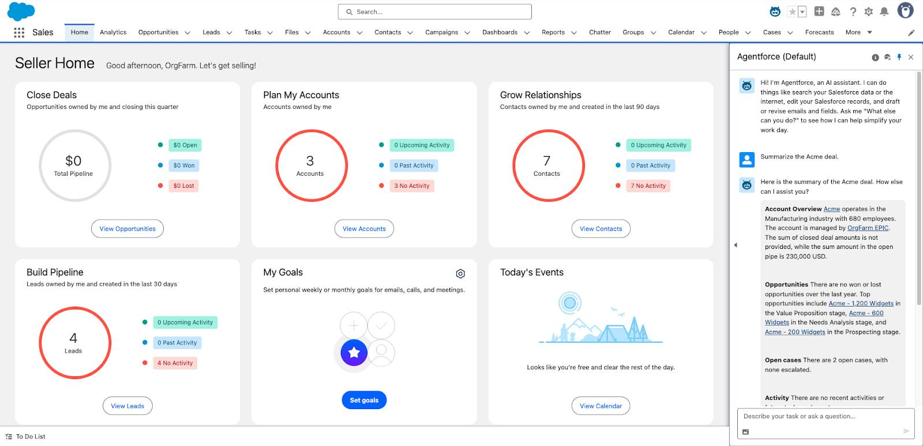
Best of all, you don’t need to know a stitch of code to set up an AI agent in Salesforce. All you have to do is enable Agentforce and then create an agent. Here are some actions an AI agent can take out of the box.
- Summarize Salesforce records, such as opportunities, accounts, and cases.
- Draft or revise emails.
- Find and update Salesforce records.
- Aggregate Salesforce data.
- Answer questions with information from your knowledge base.
On top of that, it’s easy to extend your AI agent by using your existing Salesforce Platform. For example, if you already have a flow in Salesforce that makes product recommendations, you can add that capability to an agent with just a few clicks.
Agentforce Characteristics
Let’s take a closer look at each characteristic of Agentforce so you can get more familiar with your new digital companions.
Trusted
At Salesforce, Trust is our #1 value. That’s why we build generative AI tools like Agentforce with Trust at the core.
Your AI agents respect Salesforce’s standard access controls, ensuring secure actions. Agentforce integrates with the Einstein Trust Layer, a secure AI architecture built into the Salesforce Platform. You get the benefits of generative AI without compromising customer data, and you can use trusted data to enhance AI responses.
Here’s how it works:
- Data grounding: The Trust Layer grounds and enriches generative prompts with trusted company data.
- Zero-data retention: Your data stays safe; it’s never retained by third-party large language model (LLM) providers.
- AI monitoring: AI interactions are logged, giving you visibility into each user interaction.
For critical scenarios where accuracy is key, agents can seamlessly transfer the conversation to a human. For example, if a user needs help with a complex issue like resetting a password and prefers a human touch, an agent verifies their identity, then promptly transfers the conversation for personalized support.
Proactive
Some AI agents aren’t just reactive, they’re proactive, which is essential in dynamic business environments. AI agents use the reasoning engine in Agentforce to perform the reasoning and acting process. The reasoning engine helps agents automate routine tasks, handle tedious duties, and find the right solutions for customers. This simplifies the process for service reps at Cloud Kicks, making their jobs easier and more efficient.
Here’s how AI agents use reasoning to enhance these actions.
Case Status Update:
- Reason: The agent reviews the case context, current status, and recent updates.
- Act: The agent notifies the customer of changes or escalates the issue to a higher-level support team.
- Observe: The agent monitors the case outcome and adjusts its approach to ensure efficient resolution.
Email Received:
- Reason: The agent reviews the email content and the nature of the request.
- Act: The agent processes the email, creates a new support ticket, or routes it to the relevant department.
- Observe: The agent monitors the response to ensure the issue is handled correctly, making adjustments if needed.
Sales Follow-Up:
- Reason: The agent reviews the customer's interest and the context of their inquiry.
- Act: The agent schedules a follow-up call with a sales representative to keep the lead engaged.
- Observe: The agent monitors the follow-up outcome and adjusts its approach to improve future interactions.
Natural Language
A conversational interface lets people ask questions or give instructions in natural language, just like talking to a human. Agentforce retains the conversation context, making follow-up questions and related requests seamless.
For example, instead of navigating the Salesforce UI to find records, a sales rep can simply type, “Show me my Acme deals.” The AI agent interprets the request, responds in natural language, and displays a list of matching opportunities. It feels just like chatting with a trusted colleague.
In the same conversation, the sales rep can then ask, “Show me their open cases.” The AI agent remembers the context and knows “their” refers to Acme. This capability ensures multiple, coherent, and efficient interactions.
But with Agentforce, you're not limited to conversational interfaces and chat windows. You can trigger an agent to complete background or event-driven tasks from anywhere you can call a flow or Apex class.

Agentforce Versus Einstein Bots
Not sure about the difference between Agentforce and Einstein Bots? Bots require a lot of expertise and time to set up, and they’re based on complex, strictly defined conversational rules.
Agentforce is flexible and requires less configuration because it’s powered by an LLM. For more information, see What’s the Difference Between an AI Agent and a Chatbot?
Dynamic Information Retrieval
Dynamic information retrieval makes AI agents highly effective at handling complex tasks. Here’s how it works.:
- Retrieval augmented generation (RAG): Agents use semantic search on structured and unstructured data in Data 360 to fetch relevant info from external sources and databases.
- Generic information retrieval tools: Tools like web search and knowledge Q&A help agents handle complex tasks. For instance, you can research a company or product online and combine it with internal knowledge to create an email summary.
- Deployment in Flows, APIs, and Apex Classes: Agents can be deployed in these environments, passing all contextual information to the agent. This eliminates the need for custom solutions in each scenario, making the agent more versatile and efficient.
Now that you see how Agentforce enhances seamless customer interactions and automates tedious tasks, let’s revisit that initial conversation and see the transformation with Agentforce in action.
Customer (Alex): “Hi, I just placed an order for a pair of custom sneakers. Can you tell me when it will be delivered?”
Agentforce: “Hello, Alex! Your order will be shipped within the next 2 to 3 business days and should arrive at your address within 5 to 7 business days after shipping. Is there anything else you’d like to know about your order?”
Alex: “Thanks! Do you have any stores in New York City?”
Agentforce: “We don’t have any physical stores in New York City, but we have a popup shop opening next month at 123 Fashion Avenue from October 1 to October 15. You can also shop online for the latest styles.”
Alex: “Awesome, thanks! One more thing—do you have any recommendations for a good running trail in New York City?”
Agentforce: “Certainly! For a great running trail, I recommend Central Park’s Reservoir Loop, which is 1.58 miles and offers beautiful views. For a longer run, try the Hudson River Greenway, which stretches for about 13 miles. Enjoy your run!”
Alex: “That’s perfect, thanks so much for all the information!”
Agentforce: “You’re welcome, Alex! If you have any more questions, feel free to reach out. Have a great day!”
Wow, talk about more helpful! Each question was answered with specific details without any pauses or vague responses. Linda is convinced, and eager to start using Agentforce.
Follow along as Linda explores the different components of Agentforce and learns more about how the feature works.
Resources
- Trailhead: Generative AI Basics
- Trailhead: Large Language Models
- Trailhead: Prompt Fundamentals
- Trailhead: The Einstein Trust Layer
- Blog: AI Is Coming—Here’s How to Get Ready
- Salesforce Help: Einstein Generative AI
- Blog: What’s the Difference Between an AI Agent and a Chatbot?

Explore Agentforce
Learning Objectives
After completing this unit, you’ll be able to:
- Define what topics and actions are.
- Explain the difference between standard versus custom topics and actions.
A Look Under the Hood
Before Linda sets up Agentforce, she wants to explore its different components and learn what makes Agentforce tick.
How Agentforce Works
Agentforce has four basic components: the agent, topics, actions, and the reasoning engine.
Agent
Previously, you learned that Agentforce includes tools for creating, customizing, and testing AI agents that perform tasks and business interactions. Currently, you can customize and launch agents for your employees and customers. See Agent Types and Considerations to learn about the different agent types and default templates for specific clouds and use cases. Here are a few examples:
- Agentforce Employee Agent: Help your employees across a wide range of workflows and tasks by giving them access to the Employee Agent, which is seamlessly built into the Salesforce interface.
- Agentforce Sales Coach: Offer personalized coaching to help your sales reps handle challenging conversations and improve performance.
- Agentforce for Service: Support your customers intelligently by resolving common inquiries autonomously and processing incoming cases.
- Agentforce SDR: Scale your sales team and make the most of your pipeline by handling new or updated leads, sending customized intro emails, responding to replies, and connecting qualified leads with sales reps.
These AI agents are goal-oriented and autonomous, and they can perform business tasks and make data-driven decisions. But how exactly does that happen? That’s where topics and actions come in.
Topics and Actions
Agents are made up of topics, which define the different jobs an agent can do. Topics include natural-language instructions that tell the agent how to make decisions and what it should and shouldn’t do.
Topics also contain a set of actions, which are the tools the agent uses to do its job.
For example, an Order Management topic might include these actions.
- Get Order by Order ID
- Get Order by Email Address
- Look Up Return Status
- Create Return Label
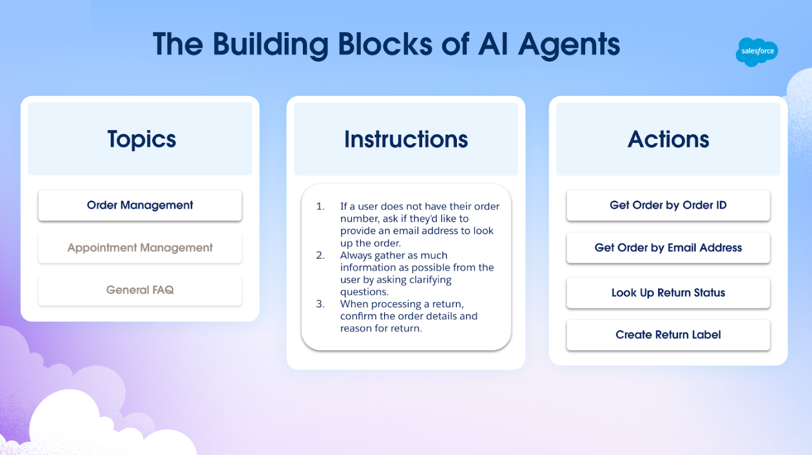
Like topics, actions also include a set of instructions. Action instructions are crucial because they tell the agent what the action does. The names, instructions, inputs, and outputs for agent actions determine when and how an action is used. The better the instructions, the more predictably the action performs, which leads to more reliable interactions.
The Importance of Topics
Just like it’s important to establish a topic in a person-to-person conversation, topics help an agent recognize and organize how to behave and respond. When you define topics, you set clear boundaries and context. This helps your agent focus on specific tasks, which leads to more consistent and appropriate interactions.
When a user asks a question or makes a request, your agent picks the relevant topic and launches the appropriate actions within that topic. This focuses your agent on the most relevant actions and data for the current conversation.
Standard Versus Custom
Salesforce provides some standard topics and actions for Agentforce out of the box, so you can get up and running quickly. But you can also create custom topics and actions to give your AI agent the ability to perform tasks specific to your business. Let’s look at both, so you can decide when to use standard versus custom topics and actions.
Standard and Custom Topics
First, let’s go over standard and custom topics.
Standard Topics
Salesforce offers a library of standard topics for common use cases. Standard topics are predefined and come with a set of commonly used actions for various business scenarios. They’re a great starting point for many organizations: They cover a wide range of tasks and are perfect for quick implementation.
Here are a few examples of topics provided by Salesforce, along with a brief description.
Topic Name | What It Does
General CRM | Handles user requests that are related to Salesforce CRM data, such as identifying, summarizing, or updating records, drafting or refining emails, aggregating data, and finding Salesforce objects.
Close Deals | Provides sellers with recommendations to close deals based on past deals won, conversation signals, and customer sentiment. Sellers also get answers to product-related pricing questions and suggestions for plans to help them close deals.
Marketing Campaigns | Drafts compelling, branded briefs and campaigns in Marketing Cloud.
Keep in mind that some topics are tailored for specific clouds or licenses, so they might need additional permissions or licenses. To learn more about standard topics, see the Resources section.
Custom Topics
Custom topics help you tailor an agent to meet specific business needs. Define a topic, actions, and instructions that align with your unique processes and requirements.
Let’s check back in with Linda to see how Cloud Kicks might use custom topics. Cloud Kicks offers a wide range of custom sneakers, and the order fulfillment process is quite complex. Linda decides to create a Shipping Management custom topic.
For example, a customer might ask, “Do you have the blue custom sneakers in stock? And can I get them next week?”
The custom topic and its assigned actions guide the agent to check the inventory, review shipping options, and confirm the delivery date.
To learn more about custom topics, see the Resources section.
Standard and Custom Actions
Now that you’re an expert on topics, let’s dive into standard and custom actions. Actions are the tools that an agent uses to get things done.
Standard Actions
Standard actions handle general use cases and perform a variety of functional tasks from simple queries to complex operations. Similar to standard topics, Salesforce offers a library of standard actions. Some are available to all users with Agentforce access, while others require additional licenses for specific clouds or products.
The table shows a few standard actions provided by Salesforce, along with a brief description. Some of these actions are system actions, which are critical and can’t be removed.
Action Name | What It Does
Query Records (Beta) | Finds and retrieves Salesforce records based on the user’s request and specific conditions, such as the values of fields. For example: “Find all open opportunities set to close this quarter sorted by created date.”
Summarize Record | Summarizes a single Salesforce CRM record. For example: “Create a summary for the Acme deal.”
Draft or Revise Email | Creates an email draft or revises the latest version of a generated email based on the user’s input. For example: “Help me write an intro email to Steve from Acme.”
Answer Questions with Knowledge | Answers a question from a user based on information from relevant knowledge articles. For example: “What is the policy for returns over 30 days?” (Requires a Knowledge license.)
To see all the available standard actions, check out the documentation.
Custom Actions
If you need to customize your agent for business-specific processes and workflows, create custom actions for your topics. The best part? You don’t have to start from scratch. Custom actions use Salesforce technologies you already know and love.
When you create a custom action, you build it on top of existing platform features, like invocable and REST Apex classes, autolaunched flows, prompt templates, and external services.
For example, you can use flows to connect to MuleSoft APIs or Apex and flows to connect to third-party APIs. You can also use Apex or flows to access engagement data, website data, or third-party data through Data 360. By making this functionality available in Agentforce, you unlock a ton of value and use cases.
If you want to get hands on with agent actions, check out the Quick Start: Agent Actions badge.
The Final Building Block of Agentforce
Now that Linda understands how topics and actions work, it’s time to introduce the powerful component of Agentforce that orchestrates everything behind the scenes: the reasoning engine.
Resources
- Salesforce Help: What Are Agents?
- Salesforce Help: Best Practices for Writing Topic Instructions
- Salesforce Help: Best Practices for Agent Action Instructions
- Salesforce Help: Agent Actions
- Salesforce Help: Standard Agent Topic Reference
- Salesforce Help: Create a Custom Topic
- Video: Get Started with Agent Actions for Developers
- Video: How to Use Prompt Templates as Agent Actions
- Video: Build Custom Agent Actions Using Apex

Meet the Reasoning Engine
Learning Objectives
After completing this unit, you’ll be able to:
- Define what the reasoning engine is.
- Explain how the reasoning engine works.
Putting It All Together
Topics and actions are the building blocks of an agent, and they’re pretty powerful, right? But how does an agent know when to launch these topics during conversations? Let’s meet the reasoning engine behind Agentforce.
What’s a Reasoning Engine?
Think of the reasoning engine as the conductor of an orchestra. Just like a conductor keeps time and guides musicians, the reasoning engine orchestrates how topics and actions handle a user’s request.
Here’s the breakdown.
- Interpret the user’s request. When a user starts a conversation, the reasoning engine interprets the request and classifies it into a specific topic. For example, if you ask, “When will my order be delivered?,” the engine classifies it as the Order Management topic.
- Build a plan for accomplishing the goal. The reasoning engine then processes each step to accomplish the goal. It considers the context, previous interactions, and available data when breaking the problem down.
- Use data to change behavior and respond to the user. When the agent finds and reviews the data from topics and actions, the results can provide a wealth of additional information. This empowers the agent to respond dynamically and make better decisions. The insights the agent gains can show potential pathways and significantly influence the next steps of the plan.
Remember that scenario at the beginning of the module with Alex and Agentforce? Let’s analyze it and see the reasoning engine in action.
Customer (Alex): “Hi, I just placed an order for a pair of custom sneakers. Can you tell me when it will be delivered?”
Agentforce: “Hello, Alex! Your order will be shipped within the next 2 to 3 business days and should arrive at your address within 5 to 7 business days after shipping. Is there anything else you’d like to know about your order?”
- Interpret the user’s request: The reasoning engine classifies this as the Order Management topic.
- Build a plan for accomplishing the goal: It queries the order database to confirm the shipping timeline and provides a clear response.
- Find and launch the right topics and actions: The agent retrieves the shipping information and provides a detailed response.
Alex: “Thanks! Do you have any stores in New York City?”
Agentforce: “We don’t have any physical stores in New York City, but we have a popup shop opening next month at 123 Fashion Avenue from October 1 to October 15. You can also shop online for the latest styles.”
- Interpret the user’s request: The reasoning engine classifies this as the Store Locations custom topic.
- Build a plan for accomplishing the goal: It takes the next step of searching the company’s store locations and upcoming events to solve requests.
- Find and launch the right topics and actions: Given the lack of stores, the agent provides alternative information about the popup shop and online shopping options.
Alex: “Awesome, thanks! One more thing—do you have any recommendations for a good running trail in New York City?”
Agentforce: "Certainly! For a great running trail, I recommend Central Park’s Reservoir Loop, which is 1.58 miles and offers beautiful views. For a longer run, try the Hudson River Greenway, which stretches for about 13 miles. Enjoy your run!"
- Interpret the user’s request: The reasoning engine classifies this as the Local Recommendations custom topic.
- Build a plan for accomplishing the goal: It accesses a database of local recommendations and selects the most relevant options.
- Finds and launches the right topics and actions: The agent provides detailed recommendations for running trails in New York City.
Alex: “That’s perfect, thanks so much for all the information!”
Agentforce: “You’re welcome, Alex! If you have any more questions, feel free to reach out. Have a great day!”
In this scenario, the reasoning engine handles the initial request about order delivery then seamlessly transitions to other topics like store locations and local recommendations. The reasoning engine can tackle topic changes and complex situations, ensuring a smooth and satisfying experience for the customer.
Time for Action
Linda’s feeling more confident now that she knows how Agentforce works, and she’s ready to take it for a spin. We suggest you do the same! Here are some suggested Trailhead badges to continue learning about Agentforce.
- Agentforce Builder Basics
- Quick Start: Build Your First Agent with Agentforce
- Connect Data 360 to Agentforce and Prompt Builder
Now that you have a solid grasp of both standard and custom topics and actions and the reasoning engine, you’re ready to plan, build, and customize your own agents with Agentforce. Explore our resources to learn more about Agentforce and get hands on with Trailhead badges.
Resources
- Trailhead: Agentforce: Agent Planning
- Trailhead: Be an Agentblazer
- Video Playlist: Agentforce Decoded

Agentforce builder basics

Get Started with Agent Builder
Learning Objectives
After completing this unit, you’ll be able to:
- Enable and locate Agentforce in Setup.
- Describe the options available on the Agentforce Agents screen.

New Agentforce Builder Generally Available!
Agentforce has gotten an upgrade! In February 2026, the new agent building experience became generally available. This badge uses the legacy builder instead of the new builder, but it’ll be updated soon. To get started with the new builder now, complete the Take a Tour of the New Agentforce Builder trail or read more in the Agentforce documentation.
Trailcast
If you'd like to listen to an audio recording of this module, please use the player below. When you’re finished listening to this recording, remember to come back to each unit, check out the resources, and complete the associated assessments.
Prerequisite Badges
Before you start this module, we recommend you complete the following modules. The work you do here builds on the concepts explained in that content.
- Introduction to Agentforce
- Introduction to Agentforce Builder
- Agentforce Basics
Your Business Needs Custom Agentforce Agents
Building a digital labor force is top of mind for many organizations that want to more effectively help their customers and make it easier for their employees to focus on what’s important. Agentforce Builder is the low-code tool where you build your Agentforce and choose options that define each agent’s role, unique skills, access, and settings that qualify them for the jobs you want them to do.
An agent is the result of a series of customization decisions you make as you build it. Once built, you use additional features of Agentforce Builder to further customize and refine your agent by writing natural language instructions, choosing your own business logic like flows, Apex, or prompt templates, and the data your agent needs to do its job. In this module, we show you how a unique agent is built using Agentforce Builder and some of the many ways it can be customized to perform its job.
Digital Labor for a Digital Agency
Opal Media Productions is an agency that creates large-scale multimedia installations for all types of events and spaces, including arenas, shopping centers, city art fairs, and corporate events. The event planners at Opal Media are always busy, and they each specialize in different types of media installations. These factors make the initial stages of engaging with prospective clients challenging because they often need to reassign a client to a planner who specializes in a particular type of installation.
Ryan Mendez is the Salesforce admin at Opal Media, and he’s learning about building an Agentforce to help its event planners handle some of the administrative tasks that distract from their creativity and time spent with their current clients. To start, he wants to create a way to channel new event inquiries through Opal Media’s website to gather information from prospective clients. This way, the whole team can determine who has the skills and capacity to follow up. Ryan thinks this is the perfect way to learn how to build an agent using Agentforce Builder.
Enable Agentforce
Ryan has been reading a lot about Agentforce over the past few months, and is eager to see what it can do. Because he’s the Salesforce Admin, he’s able to assign himself the permissions to use it. Next, he needs to enable it in Opal Media’s Salesforce org. Here’s how he does it.
- He clicks Setup  and selects Setup.
- In the Quick Find box, he searches for and selects Einstein Setup.
- On the Einstein Setup page, he makes sure the Turn on Einstein toggle is set to the On position. (Depending on your org, Turn on Einstein may already be toggled on.)
- He refreshes the browser window.
- In the Quick Find box, he searches for and selects Agentforce Agents.
- On the Agentforce Studio | Agentforce Agents page, he toggles the Agentforce button to the On position.
- He refreshes the browser window again to activate additional Agentforce features.
Agentforce Studio
Agentforce Studio is an app in Setup where Ryan can create and manage agents, access agent topics and actions in the Agentforce Asset Library, and view agent session details with Agent Analytics. With Agentforce enabled, he simply types AgentforceCopy in the Quick Find box to access Agentforce Studio.
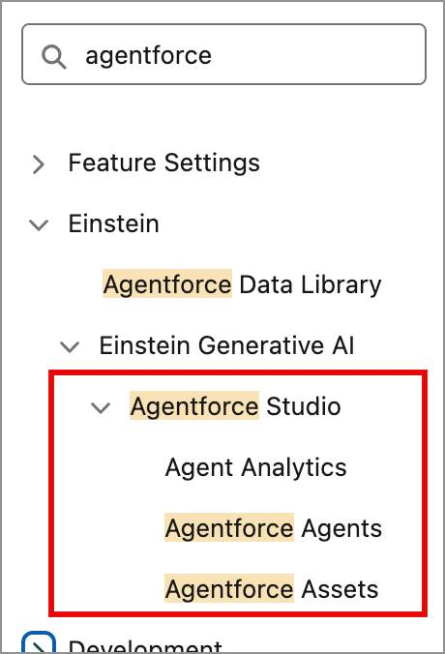
Ryan clicks the Agentforce Agents link to open the Agentforce Agents screen. Here he can:
- Access agents he built and the Agentforce (Default) agent. The Agentforce (Default) agent can be customized for his employees to use right in the flow of their work. (Note: You can learn more about customizing the Agentforce (Default) agent in the Agentforce Basics Trailhead module (1).)
- Find resources where he can learn more about Agentforce Agents through other Trailhead modules, blogs, and Salesforce Help documentation (2).
- Create and customize a new agent using Agentforce Builder (3).
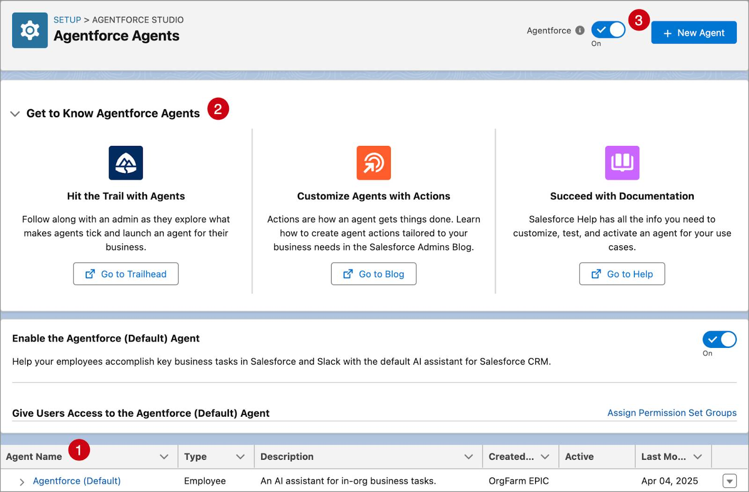
With Agentforce enabled, Ryan can start building an agent to gather details on potential multimedia projects for Opal Media’s event planning staff. In the next unit, follow along with Ryan as he builds an agent using Agentforce Builder’s guided setup.
Resources
- Trailhead: Agentforce Basics

Build and Customize an Agent
Learning Objectives
After completing this unit, you’ll be able to:
Build a new agent.
Preview your new agent.
Customize your agent’s topic instructions.
Trailcast
If you'd like to listen to an audio recording of this module, please use the player below. When you’re finished listening to this recording, remember to come back to each unit, check out the resources, and complete the associated assessments.
Build an Events Inquiry Agent
Now that Ryan has enabled Agentforce, he’s eager to see if building an agent is really as easy as it sounds.
He clicks  to launch Agentforce Builder.
As he looks around the Agentforce Builder interface, he sees a panel on the left called Steps. This panel helps him know where he is in the agent-building process. The center panel is where he selects options or enters the details that define his agent. The right panel contains in-app guidance that updates as he moves through the agent-building process. There are four steps involved in building an agent, and Ryan is excited to know he’ll have a new agent so quickly.
Step 1: Select an Agent
In the first step, Ryan sees several tiles in the center column containing agent types and their descriptions. He can choose one of the preconfigured agent types, or he can create a brand-new agent from a template or use generative AI to create one for him. After reading the descriptions on each tile, Ryan decides that the Agentforce Service Agent is the best agent type to gather event details from prospective clients. (Note: The preconfigured agent types you see in Step 1 depend on the Salesforce licenses your company has purchased.)
He clicks the Agentforce Service Agent tile, then clicks Next.
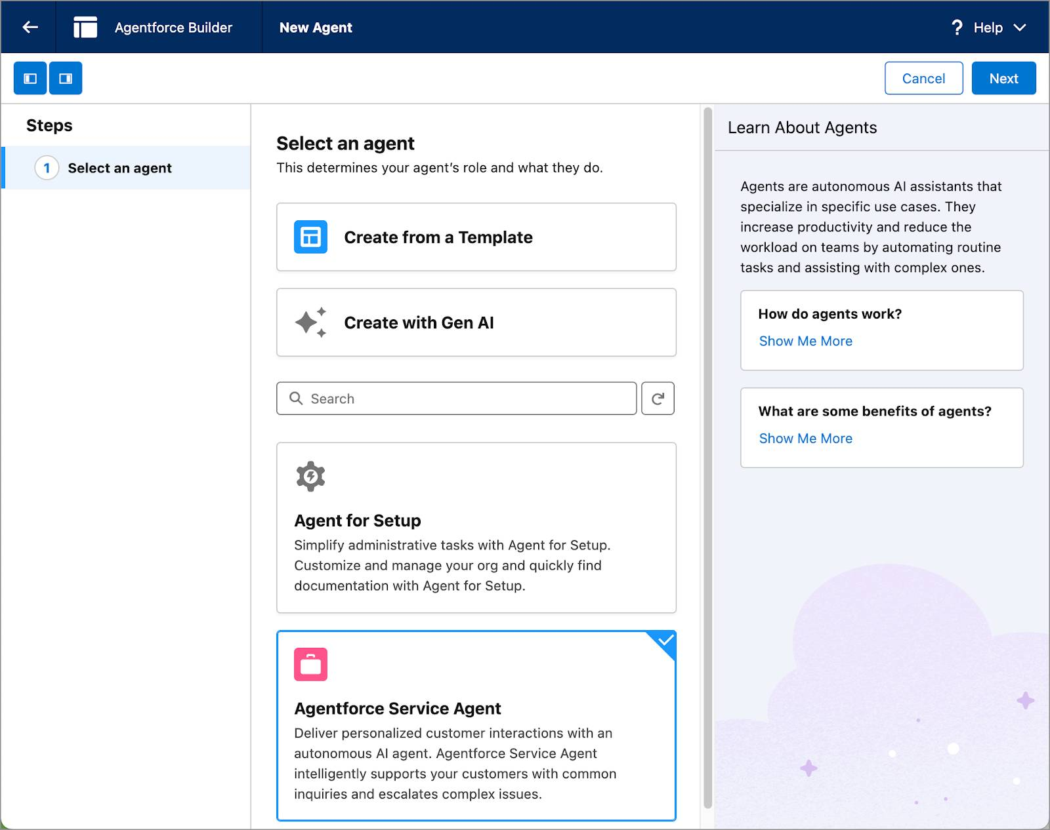
Step 2: Select Your Topics
Topics are the overall categories of jobs, or actions, that an agent can perform. The topics Ryan sees in this step are determined by the agent type, Agentforce Service Agent, he just selected. If he had selected a different agent type, he'd see different topic options. He notices that several topic tiles have a link called See Included Actions.
On the Reservation Management topic tile, Ryan clicks See Included Actions. This displays a menu of actions that are preconfigured for jobs related to making and managing reservations.
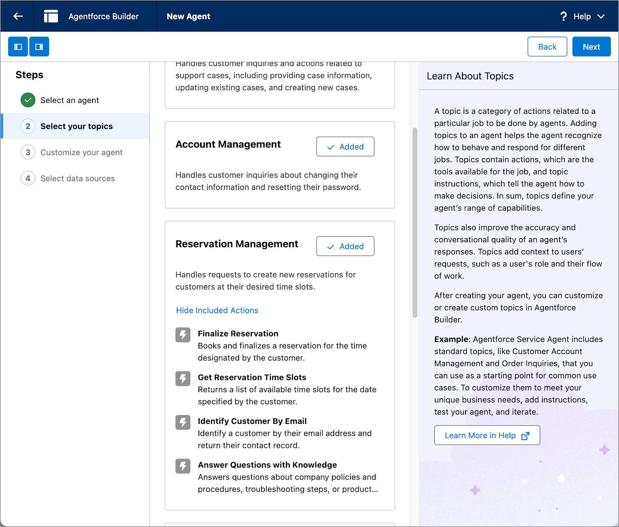
He clicks Hide Included Actions to close the actions menu.
The agent he’s creating doesn’t need to include all of the topics listed with the Service Agent, so he removes several of them that aren’t relevant to the jobs his agent will perform.
He clicks  on the Reservation Management, Delivery Issues, and Order Inquiries tiles to remove them from the agent. Notice that the button changes to . If he decides he needs a topic he didn’t include, he can add it later from the Agentforce Assets screen in Agentforce Studio.
He clicks Next.
Step 3: Customize Your Agent
The information Ryan enters in the fields in Step 3 are the details that define his agent and its behavior, so it’s important that he thinks about these carefully. However, he can edit his agent settings later if he needs to. Ryan looks at each field to see what kinds of information he needs to provide.
Name: Choose a descriptive name that reflects the job or jobs the agent will do so it’s easy to recognize this agent’s purpose later on.
Description: Describe the job or jobs the agent will do.
Role: Explain the role the agent will perform, including tasks and responsibilities.
Company: Describe your company and include details about what your company does, your customers, and the products or services you provide.
Agent User: Select an Agent User who has the correct permissions to access the information, objects, and fields it needs to do its job. Agent User permissions can be configured in User Settings.
Keep a record of conversations with Enhanced Event Logs to review agent behavior: Capture each interaction an agent has with users, including the actions the agent took to return responses. View event log interactions in the Event Logs tab in Agentforce Builder to help test and troubleshoot an agent, or to help refine agents to give more targeted responses.
Ryan fills out the fields with the following information.
In the Name field, he enters: Event Inquiries AgentCopy. The API name field dynamically updates as he types.
In the Description field, he enters: Deliver personalized client interactions with an autonomous AI agent. Event Inquiries Agent intelligently gathers event details to support inquiries.Copy
In the Role field, he enters: You are an AI event planner whose job is to help prospective clients with new event requests by gathering details.Copy
In the Company field he enters: Opal Media Productions is a high-end interactive multimedia agency that provides state-of-the-art installations for large-scale events. Target clients are arts organizations, consumer and product lifestyle shows, sporting events, and music concerts.Copy
For the Agent User, he chooses OpalMediaProductions Inquiry.
He checks the checkbox next to Keep a record of conversations with Enhanced Event Logs to review agent behavior.
Then he clicks Next.
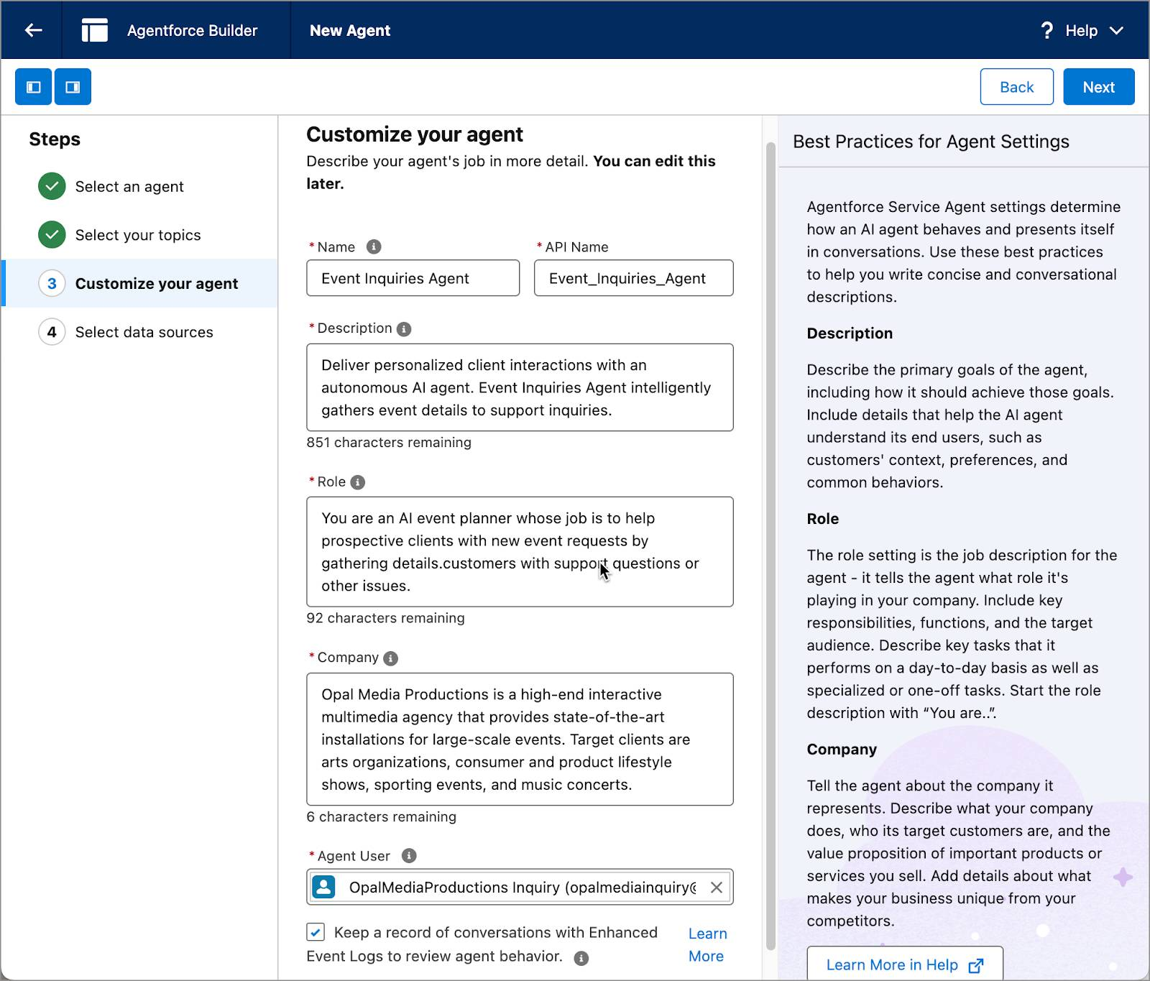
Step 4: Select Data Sources
On the Select Data Sources step, Ryan can upload data, like knowledge articles, FAQ’s, or other kinds of help documentation for his agent to reference to lend a personalized touch to conversations it has with clients. (Note: Data that you include with your agent requires Data 360 to be turned on, which can incur additional costs. Many jobs agents perform don’t require data at all, so you don’t always need to include data. You can always edit your agent to add data later on.)
Ryan won’t select any data to use at this time.
He clicks Create.
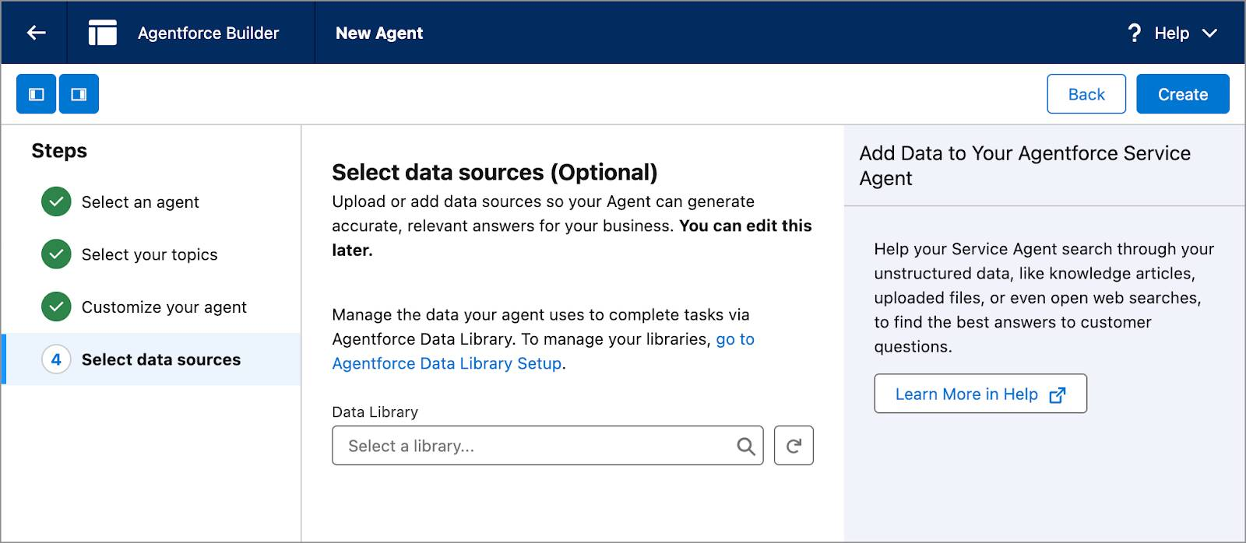
Hooray! Ryan’s agent is created! The new Event Inquiries Agent opens in a new screen Agentforce Builder where he can customize his agent, and start a conversation with it to test and refine its responses.
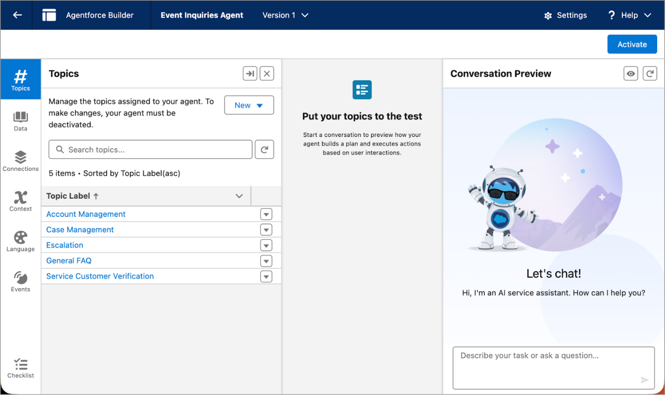
What’s Next?
With Ryan’s new agent built, follow along with Ryan as he uses Agentforce Builder to customize the agent's topics and topic instructions and shape how it responds.
Resources
Trailhead: Introduction to Agentforce Builder
Trailhead: Introduction to Agentforce
Trailhead: Agentforce Basics

Customize Agent Topics
Learning Objectives
After completing this unit, you’ll be able to:
- Preview an agent in the Conversation Preview panel.
- Refine and add new topic instructions.
- Explain how to add and remove topics.
Trailcast
If you'd like to listen to an audio recording of this module, please use the player below. When you’re finished listening to this recording, remember to come back to each unit, check out the resources, and complete the associated assessments.
Let’s Chat
An agent wouldn’t be your agent without customizations. The topics, actions, and settings you define when you build an agent make it unique and qualify it to do the job or jobs you need it to do. But that doesn’t mean it does everything you need it to do right away. Let’s look at how Ryan customizes his agent to do the jobs he needs it to do.
When Ryan clicked Create and landed on the next Agentforce Builder screen, he takes a look around. He sees three new panels.
- On the left, he sees a panel where he can customize various components for his agent (1).
- On the right, he sees a panel called Conversation Preview, where he can engage with the agent to test how his agent responds (2).
- In the center panel where it says, Put your topics to the test, he sees the Plan Tracer, which shows the work the agent does behind the scenes to generate responses to queries (3).
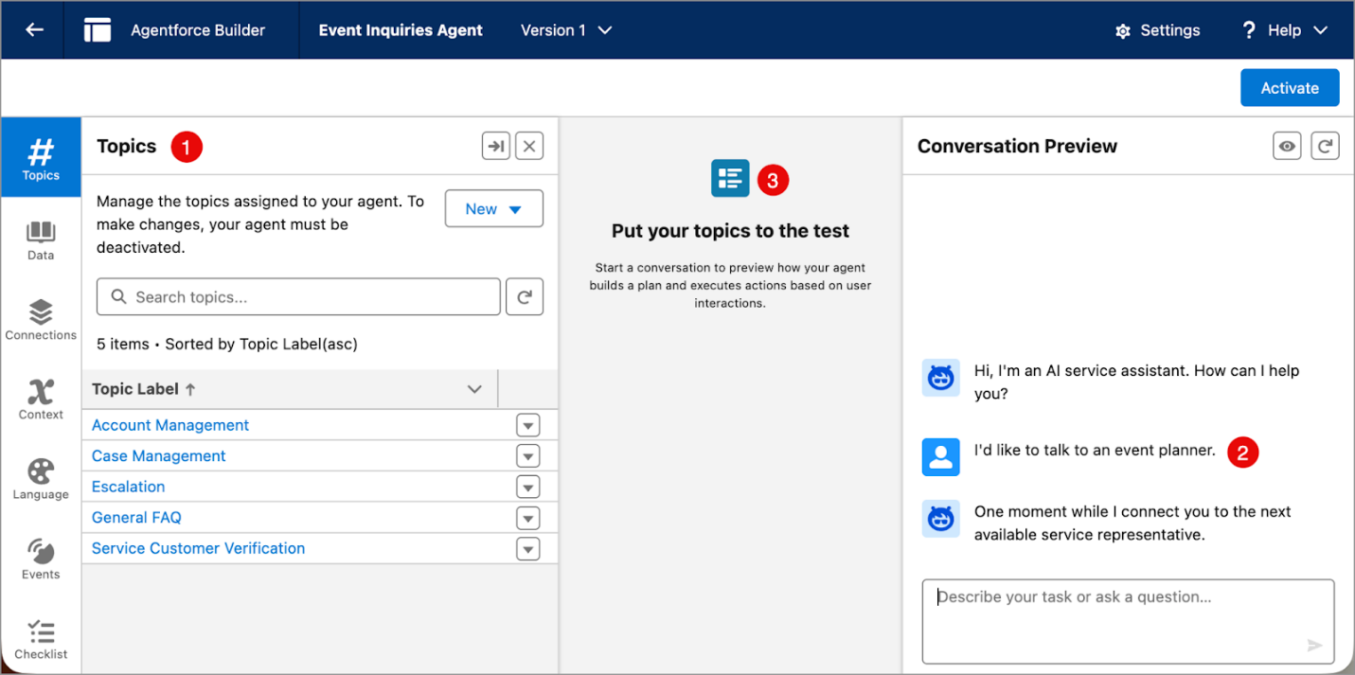
Converse with Natural Language
If you earned the Introduction to Agentforce Builder badge, you know that you engage with an agent using natural, conversational language that is routed through a large language model (LLM) and a reasoning engine to help it understand and retain context and make decisions based on the instructions and guardrails you set up.
Ryan wants to see what kind of response his brand-new agent returns. In the Preview window, Ryan types I’d like to talk to an event planner.Copy The agent replies: “One moment while I connect you to the next available service agent.”
Customize the Conversation
Not surprisingly, the new agent returned a response that’s not quite what Ryan wants. This agent, as it’s configured right now, immediately offers to connect Ryan to the next available service representative. Also, the agent isn’t personalized enough to align with the event planning services Opal Media provides. Ryan needs to customize it a bit.
Before customizing or refining an agent, it’s a best practice to read its topics, topic instructions, and actions carefully to understand why it works the way it does so you know where to begin customizing. In the left panel, on the Topics tab, Ryan clicks the Escalation topic and reads through the Classification Description, Scope, and Instruction fields.
- Classification Description: Tells the agent when to use a topic. The Agentforce reasoning engine can detect user intent and call a topic that aligns with that intent.
- Scope: Defines what an agent is able to do within the parameters of this topic.
- Instructions: Provides details of the job the agent performs. Instructions can also act as guardrails for the agent to work within.
Ryan wants to edit the text in each field to be more relevant to the job he wants this agent to perform. Here’s how he edits the fields.
- On the Escalation topic, he clicks the dropdown arrow and selects Edit.
- Then, in the Classification Description field, he types: Handles requests from clients who want to talk to a human Event Planner to plan a new event.Copy
- In the Scope field, he types: Your job is to ask the client for details about the event they want to plan so that a human event planner can follow up.Copy
- In the first Instruction field, he types: If a user explicitly asks to transfer to an event planner, tell them no event planners are available and offer instead to create a case for the events team to review.Copy
- Next to the second instruction, he clicks to delete it, then he clicks Save.
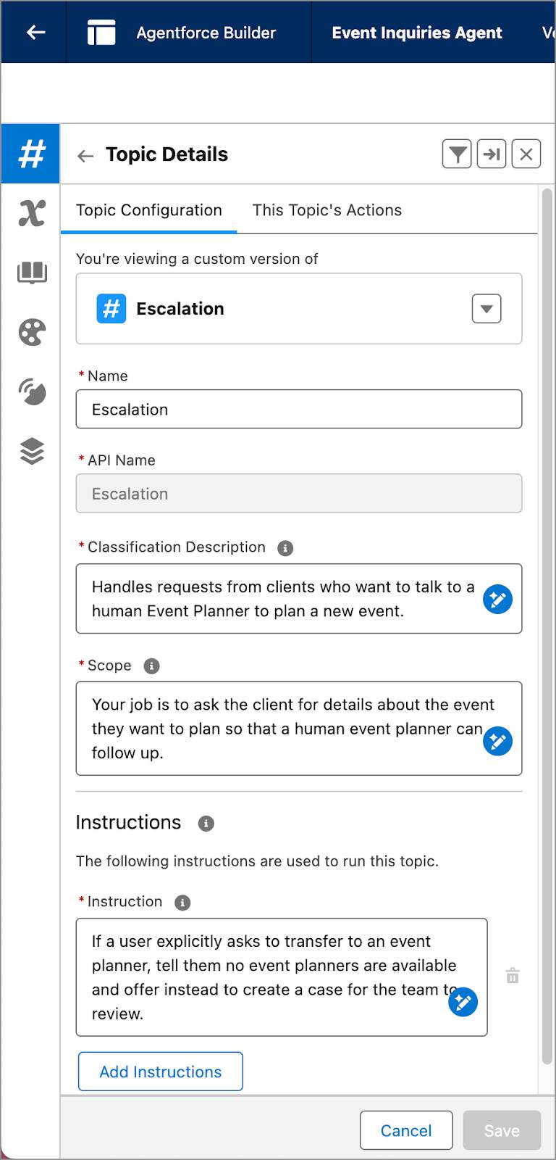
Iterate and Retest
With the changes made, Ryan retests his agent to see what happens.
- He refreshes the Conversation Preview window to apply the changes.
- In the Conversation Preview window, he enters I’d like to talk to an event plannerCopy.
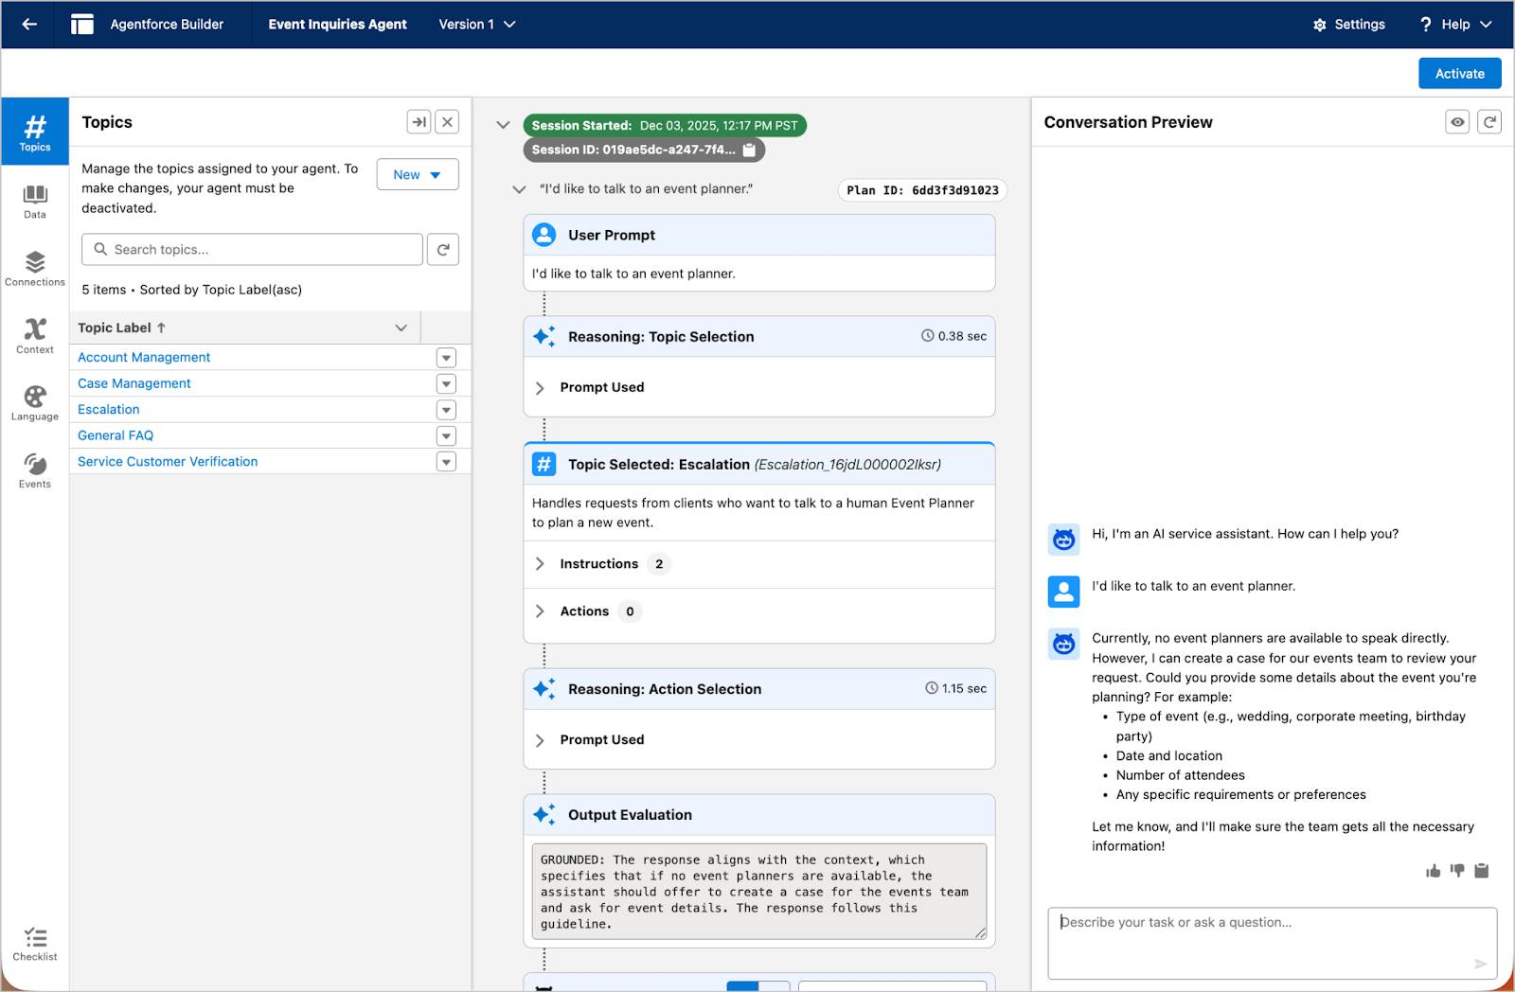
The agent responds with, “Currently, no event planners are available to speak directly. However, I can create a case for our events team to review your request. Could you please provide some details about the event you’re planning?”
Ryan is thrilled by the accuracy and detail in the new response after making only a few minor updates. The agent is already much more aligned to the job he wants it to perform. The agent picks up the context of the conversation and politely asks for details about a client’s event!
He’s also impressed that Agentforce Builder lets him see how the agent works behind the scenes. In the Plan Tracer window in the center panel, he can easily follow how the simple prompt “I’d like to talk to an event planner” first called the Escalation topic, then used his new instruction, and then verified, through reasoning, that the agent followed the context of the conversation to ground the response.
Ryan plans to refine this interaction further and also tailor a few more instructions so his agent can respond to other types of questions and gather details in a format that matches Opal Media’s records.
Add or Remove Topics
Ryan is still feeling the thrill of creating an agent that he can so easily modify to get different kinds of responses. However, when he initially built it, he wasn’t quite sure which topics he would need. Now that he understands how Agentforce Builder works and how easy it is to customize an agent with just a few clicks, he wants to remove the General FAQ topic until he gathers more details about the types of inquiries clients make. He knows he can easily add it again later.
- In the Topics Label section, he clicks on the dropdown arrow next to General FAQ and selects Remove from Agent.
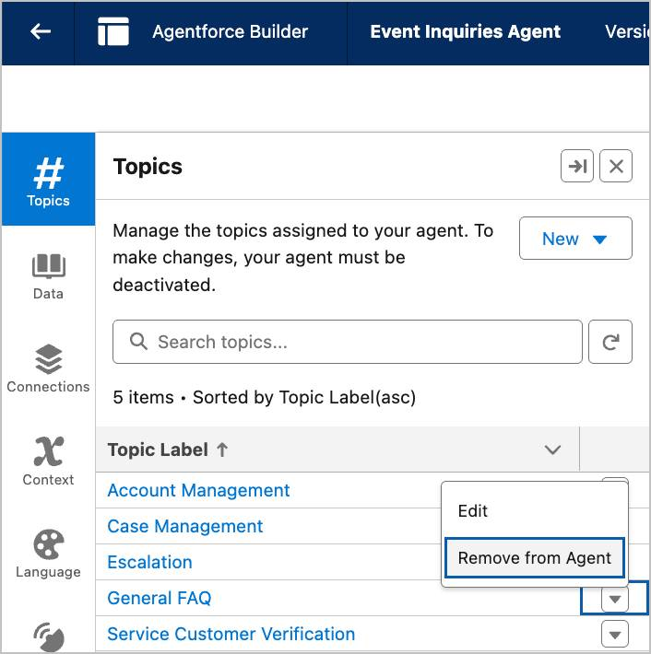
He wants to see if there are any other topics he wants to include right now.
- He clicks New.
- He selects Add From Asset Library.
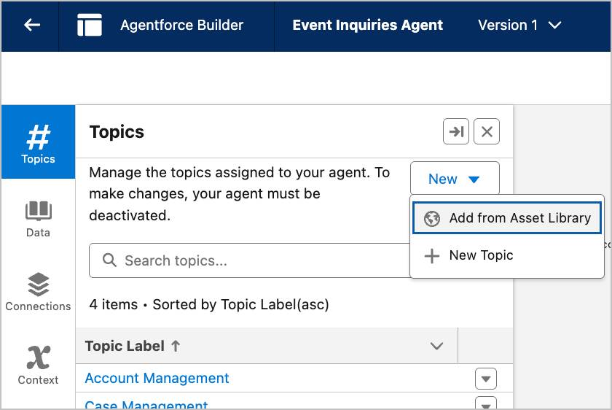
The Asset Library is a list of standard topics that can be included with the Agentforce Service Agent. Ryan can also create a brand-new topic if he doesn’t see a topic that fits his needs. It’s a best practice to use preconfigured topics and actions wherever possible because, with a few customizations, they cover almost any use case imaginable. 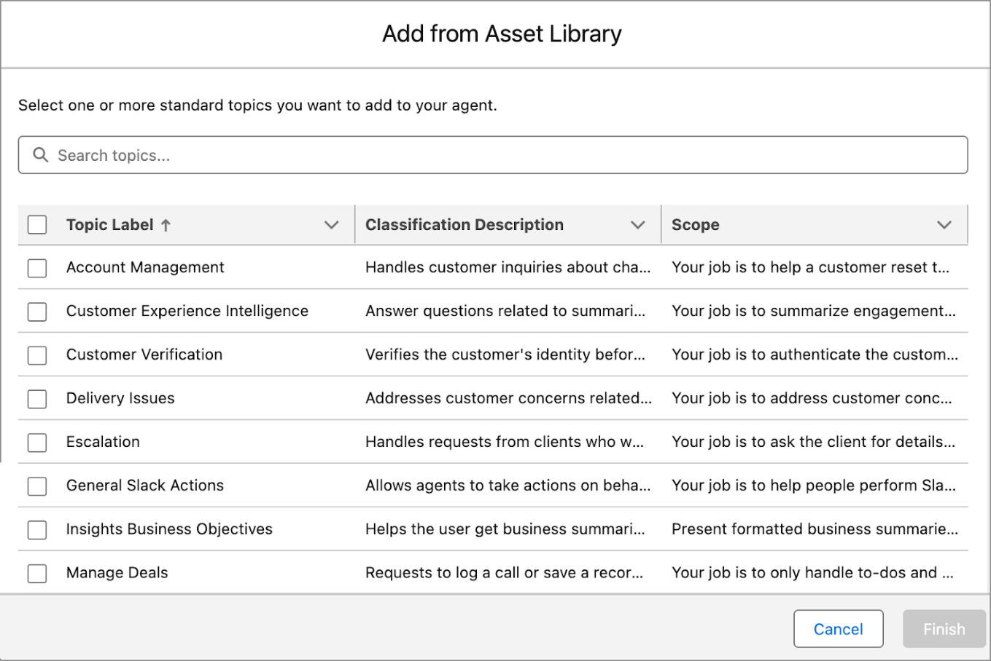
- Ryan clicks Cancel to close the asset library and return to Agentforce Builder.
Summary
You followed along as Ryan previewed his agent and refined its response. In the next unit, you customize your agent further and update its settings.

Define Agent Settings
Learning Objectives
After completing this unit, you’ll be able to:
- Locate and customize agent settings.
- Assign languages to your agent.
- View conversation details in event logs.
- Customize greeting and error messages.
Trailcast
If you'd like to listen to an audio recording of this module, please use the player below. When you’re finished listening to this recording, remember to come back to each unit, check out the resources, and complete the associated assessments.
Customize Agent Settings
Ryan is happy with how his first agent is coming along and wants to learn about other ways he can customize its components and settings to better align the agent with the work Opal Media does, and their client’s expectations. He clicks through the buttons on the left side of the screen to see what he can do with each component.
Component | Description
 | Topics: Review topics, add or remove topics, view actions assigned to a topic, and edit topic details and instructions.
 | Data: Upload documents or knowledge articles to personalize your agent’s interactions. Data 360 is required to use this feature.
 | Connections: Add your agent to multiple channels and manage their settings.
 | Context: View and edit variables and session context that power your agent.
 | Language: Set the default language and other languages your agent can respond with. Change the tone of the conversation to match your business style.
 | Events: View session data to test or troubleshoot your agent. When you create an agent and check the “Keep a record of conversations with Enhanced Event Logs to review agent behavior” setting, this button lets you see additional details, including the prompt the user entered and the agent’s response.
 | Checklist: A step-by-step agent readiness checklist so you can make sure your agent is ready to deploy.
Assign Languages and Tone
Opal Media regularly works with organizations that put on cultural events or food festivals that use themes from around the world. There are several event planners on the event staff who are bilingual and can converse in German, French, and Japanese. So Ryan wants to give his clients the ability to reach out to his agent using one of these languages.
- Ryan clicks  to open Language Settings.
- In the Default Language field, he selects English.
- In the Select Languages picker, he clicks French, then he clicks to move it to the Selected box.
- He does the same to select German and Japanese.
The team at Opal Media likes to project a relaxed and friendly vibe through its website, advertisements, and social media posts. So Ryan is happily surprised to see that he can change the tone of his agent’s conversation to better match the company's laid-back style.
- In the Tone menu, he selects Casual.
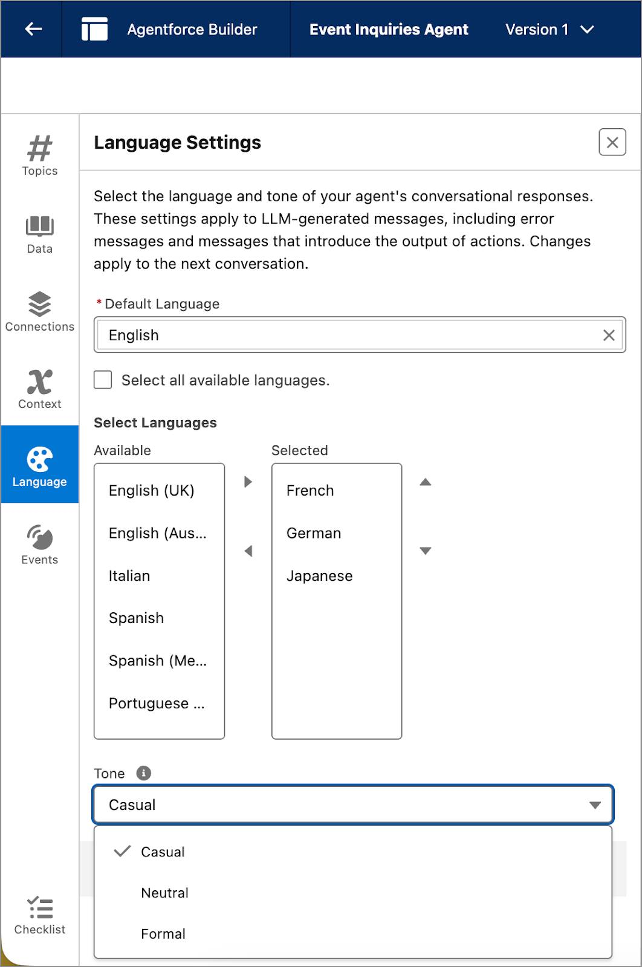
- In the Conversation Preview window on the right, he clicks the Refresh button to apply the changes to the language settings.
Ryan uses a language translation app to translate, “I’d like to plan an event” in each language he selected to check if the agent responds in that language. Since he doesn’t speak or read those languages himself, he’ll ask his colleagues to further test the language responses before he deploys the agent on Opal Media’s website.
View Events
When agents and users converse using Agentforce, data from each conversation is stored in an event log. Event logs can be reviewed to test an agent or to troubleshoot when something didn’t work as expected in a conversation. When Ryan built his agent, he checked a box called “Keep a record of conversations with Enhanced Event Logs to review agent behavior”. By checking this box, he’s able to review session activity and the entire conversation transcript, including the prompts the user types and the agent’s response. Once his agent is deployed, Ryan reviews conversations in the event logs regularly to better understand the types of questions clients ask so he can further customize the agent to respond to more types of requests.
- He clicks  to open the Events panel.
He clicks a session ID to review each step of the conversation including prompts, timestamps, agent responses, and grounding information.
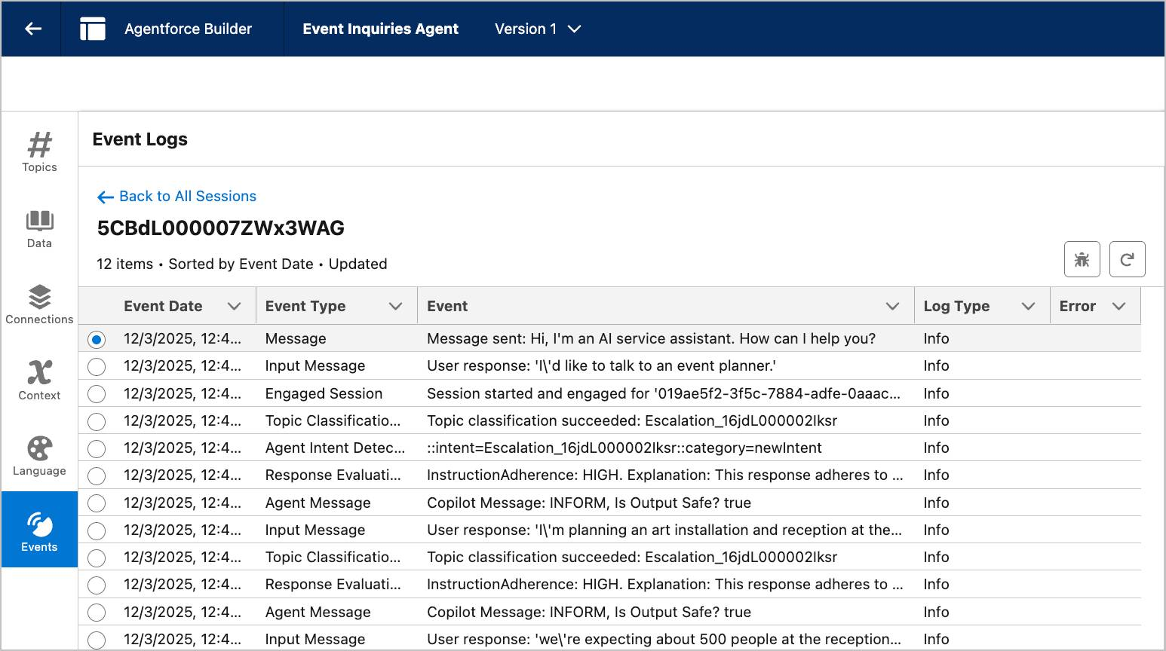
Customize Greeting and Error Messages
When Ryan previewed his agent in the Conversation Preview window, he thought it sounded too impersonal for something coming from Opal Media. It says “Hi, I’m an AI service assistant. How can I help you?” This message is the standard greeting for all Agentforce Service Agents, which, you might remember, is the agent type Ryan chose for his Events Inquiries Agent. While it’s a friendly enough greeting, Ryan wants his agent to sound more familiar to Opal's clients, and to be more consistent with the casual tone he selected in Language Settings.
- Ryan clicks  to close Agentforce Builder.
- In Agentforce Studio, at the bottom of the Agentforce Agents screen, he clicks Event Inquiries Agent to open Agent Details. Agent Details contains tabs for some of the details he included when he built his agent, details he just set up, like Language Settings, and a few other tabs that he hasn’t seen before.
- He clicks the System Messages tab.
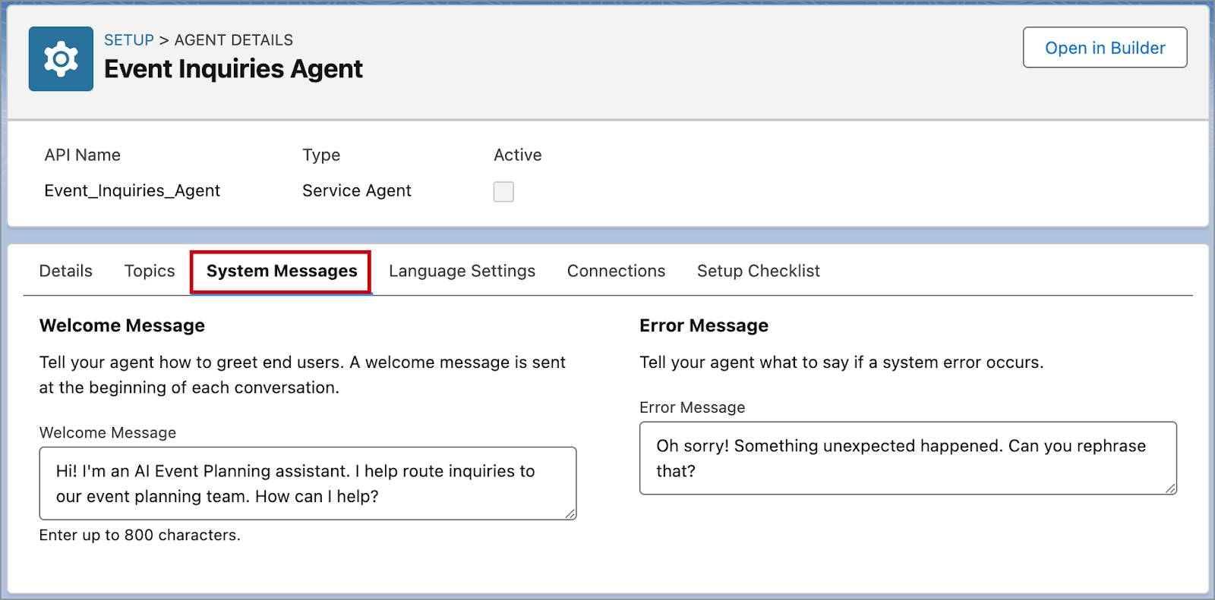
The Welcome Message field has an 800-character limit, and while Ryan doesn’t want to overwhelm his clients with text, he still wants to make sure they know they’re engaging with AI. He comes up with a few sentences that he feels are better aligned with Opal Media’s style.
- In the Welcome Message field, he enters: Hi! I’m an AI Event Planning assistant. I help route inquiries to our event planning team. How can I help?Copy
- In the Error Message field, he enters: Oh sorry! Something unexpected happened. Can you rephrase that?Copy
- He clicks Save.
- At the top of the screen, he clicks Open in Builder to see the new greeting in the preview window.
Wrap Up
At this point, Ryan would have a bit more work to do to finish customizing his agent before deploying it to Opal Media’s website. Agent building is an iterative process and you can continue to fine-tune topics, instructions, or actions to respond to different types of inquiries or needs that arise over time. For more practice customizing agents, take the Quick Start: Agent Actions Trailhead project to customize an agent with an autolaunched flow action.
Resources
- Trailhead: Quick Start: Agent Actions

Agentforce for Service

Get Started with Agentforce for Service
Learning Objectives
After completing this unit, you’ll be able to:
- Describe Agentforce for Service.
- Explain how Agentforce for Service is different from other bots.

New Agentforce Builder Generally Available!
Agentforce has gotten an upgrade! In February 2026, the new agent building experience became generally available. This badge uses the legacy builder instead of the new builder, but it’ll be updated soon. To get started with the new builder now, complete the Take a Tour of the New Agentforce Builder trail or read more in the Agentforce documentation.
Trailcast
If you'd like to listen to an audio recording of this module, please use the player below. When you’re finished listening to this recording, remember to come back to each unit, check out the resources, and complete the associated assessments.
What’s Agentforce for Service?
Agentforce for Service is a massive leap forward in customer service automation. It’s a trusted conversational AI agent that seamlessly supports customer service teams. Unlike traditional chatbots that rely on rigid, declarative dialogs, these autonomous agents use generative AI to operate 24/7 across self-service portals and messaging channels to handle tasks, make decisions, and provide natural responses aligned with branding.
Because Agentforce for Service is grounded in trusted business data and knowledge base, it delivers the most relevant, context-aware information to meet specific business or customer service goals. Agentforce for Service automates common tasks and frees up service teams to focus on more strategic, high-value work and build customer relationships.
Key Benefits of Agentforce for Service
Agentforce for Service offers flexible solutions to customer service challenges.
- Responds 24/7: Answers questions, deflects cases, and meets service goals on channels at any time of day, whenever is convenient for your customer.
- Replies naturally: Uses generative AI to craft conversational responses that understand context and match a brand’s voice.
- Adds clarity: Instructs AI agents to ask questions specific to the business to gather and share more accurate information.
- Handoffs to humans: Lets AI seamlessly transfer or escalate conversations to live agents who can solve more complex issues.
- Deploys quickly: Sets up quickly using service-specific templates and existing workflows, without the need to write dialogs, define intents, maintain conversation trees, or train large language models (LLMs).
- Grounded in trusted data: Grounds AI agents in credible sources like Knowledge articles, similar cases, and CRM data. All LLM calls from Agentforce for Service go through the Trust Layer on the Einstein 1 Platform, which keeps customer data safe.

What Makes Agentforce for Service Unique?
As business needs are assessed, there are a few key differences between Agentforce for Service and Einstein Bots.
Difference | Agentforce for Service | Einstein Bots
Setup | Sets up quickly with prebuilt topics and actions. AI agents are powered by generative AI and large language models (LLMs) to provide flexibility and conversational capabilities similar to humans. | Set up requires manually training natural language models (NLMs) to understand customer language and design dialogs.
Maintenance | Update a handful of out-of-the-box topics, actions, and instructions—or quickly create custom ones as service requests increase. Improve performance easily by adding and iterating on natural language instructions. | Requires high maintenance to keep the dialogs and intents up to date and to train new dialogs and intents as service requests increase.
Context and Exception Handling | Understands human language and responds to follow-up questions and unplanned exceptions—has context of entire conversations. | Can’t understand human language and responds only to the most recent question—has no context of entire conversations.
Although Agentforce for Service is more advanced, Einstein Bots may be ideal in a regulated industry that requires explainable processes with extra governance, or when maintenance of highly specific, deterministic conversation flows using dialogs and intents are needed.
Types of Agentforce Agents
Since Agentforce Agents can work across sales, service, marketing, and commerce, there are a few types of autonomous agents available.
Service Agent | Service Planner | SDR | Sales Coach | Employee Agent
Resolves customer cases autonomously across channels 24/7 with natural responses. | Effectively helps your service reps resolve cases faster with concise case summaries and detailed, step-by-step resolution guidance. | Helps sellers automate pipeline 24/7 by qualifying inbound leads and booking meetings for sellers. | Gives every seller a dedicated AI coach through on-demand, realistic role-plays tailored to each deal and personalized feedback. | Customizable to meet the specific needs of your company and employees to help them become more productive.
Agentforce Agents share the same building blocks on the Agentforce Platform, such as the Trust Layer and Prompt Builder.
Agentforce for Service Setup
It just takes a few steps to set up Agentforce for Service. From Setup, in the Quick Find box, search for and select New Agent. Then choose the type of agent to create.
Now you know a thing or two about autonomous agents, read on to gain an understanding of the building blocks of agents.
Resources
- Trailhead: Agentforce: Quick Look
- Trailhead: Einstein for Service: Quick Look
- Trailhead: Quick Start: Build a Service Agent with Agentforce

Learn the Building Blocks of Agentforce for Service
Learning Objectives
After completing this unit, you’ll be able to:
- Describe three key foundations of Agentforce for Service.
- Explain how Agentforce deploys actions.
Trailcast
If you'd like to listen to an audio recording of this module, please use the player below. When you’re finished listening to this recording, remember to come back to each unit, check out the resources, and complete the associated assessments.
What Drives Agentforce for Service?
One of the most powerful features of Agentforce for Service is the ability to customize how the agent functions and engages with customers. This flexibility is driven by three key elements—topics, actions, and instructions—that shape the agent’s decision-making process and power the learning model.
Topics, actions, and instructions work in unison to help Agentforce deliver the best possible responses to every interaction. A topic is created first, and then actions and instructions are created and housed under the topic. Both actions and instructions must be linked to a topic. Take a closer look at each of these features.
Topics
Topics categorize the Job To Be Done and define an agent’s role by guiding it to apply the right instructions and actions during a conversation. Think of topics as a category of tasks to be done. For instance, a topic named Account Management can include all tasks related to managing a customer account. Topics guide the agent in responding to user requests in a way that suits the user’s role, their current workflow, and the stage of the conversation. They define the specific tasks the agent can manage for each job to be completed.
Topics in Agentforce for Service require these details.
- Classification description: Determines if this is the correct topic to use based on intent.
- Scope: Defines exactly what an agent can do when this topic is being used. Think of this as telling the agent, “Right now your only job is to…”.
Agentforce Builder provides standard topics as well as the ability to create custom topics.
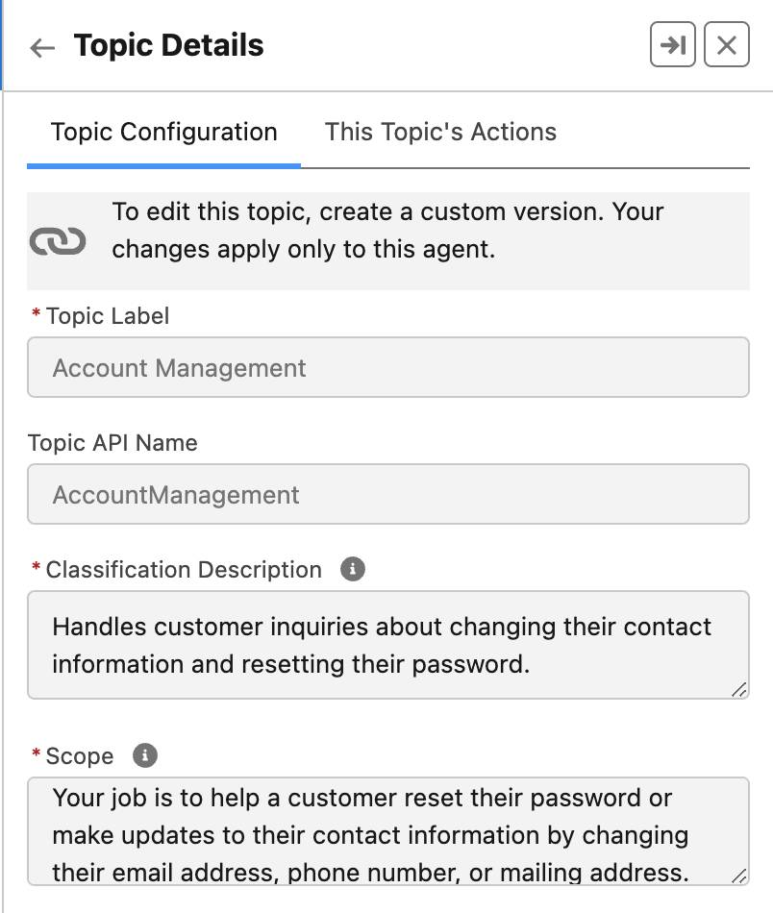
Actions
Actions define the specific tasks an agent can perform based on the selected topic. They can determine if user input is needed to trigger the action and gather additional information during the conversation. Depending on the topic and instructions, multiple actions can be triggered simultaneously. For example, actions under the Account Management topic might include tasks like summarizing account details, retrieving account-related information from a knowledge base, or drafting email responses.
Actions can be created manually or selected from a preexisting list that your company can already use. Similar to topics, Agentforce Builder offers standard and custom actions. The standard actions included might be considered private actions, potentially needing additional configuration per your security standards to function correctly.
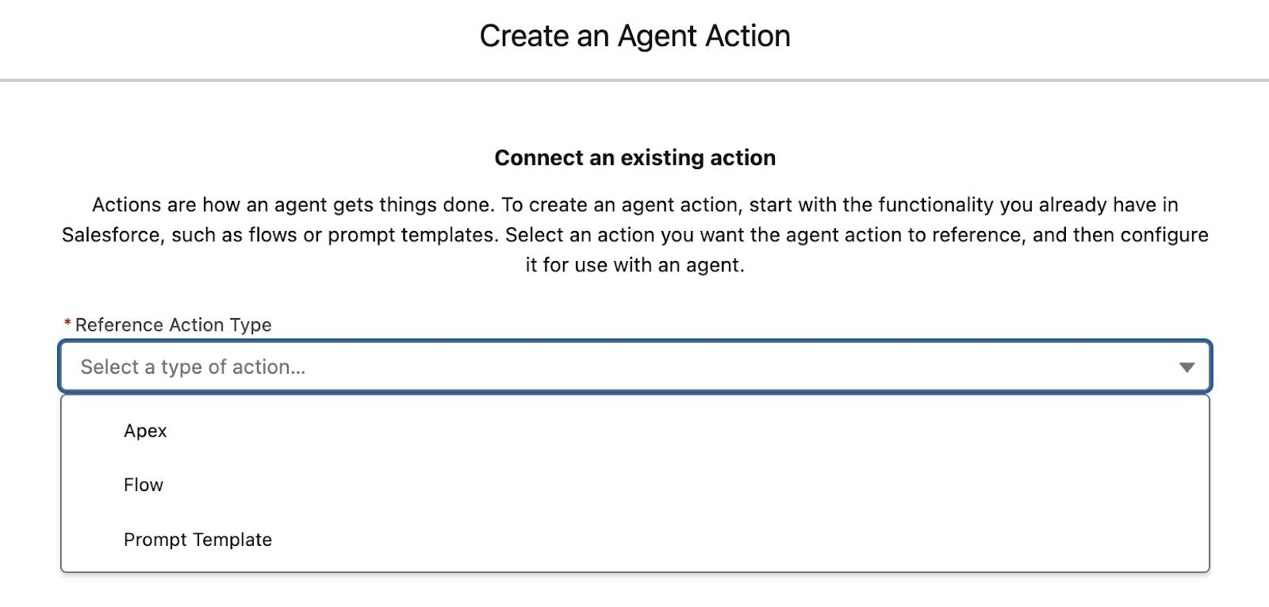
An agent action can be created manually from an Apex class, a flow, or a prompt template.
Action Type | Definition
Apex | An action that uses Apex can call classes and variables, enabling it to interact with third-party APIs or external applications. Apex is ideal for handling complex logic or enforcing intricate business rules.
Flow | Flows are used to create, update, delete, and retrieve records. Flow Builder enables automation of processes and actions within specific topics. Existing flows can also be referenced by agent actions.
Prompt Template | Prompt templates can be invoked as Agentforce actions to help agents handle queries such as knowledge search, classification, and more. A prompt template directs the LLM on what and how to respond, including the ability to choose your own model. Similar to flows, Agentforce can employ prebuilt prompt templates.
Instructions
Instructions give clear, detailed context to guide agents based on the nature of an interaction. Instructions tell agents how to make decisions. They can be highly customized to define how the agent should respond, specifying tone, style, and what types of responses to avoid. Instructions are mapped to topics and can be edited in Agentforce Builder.
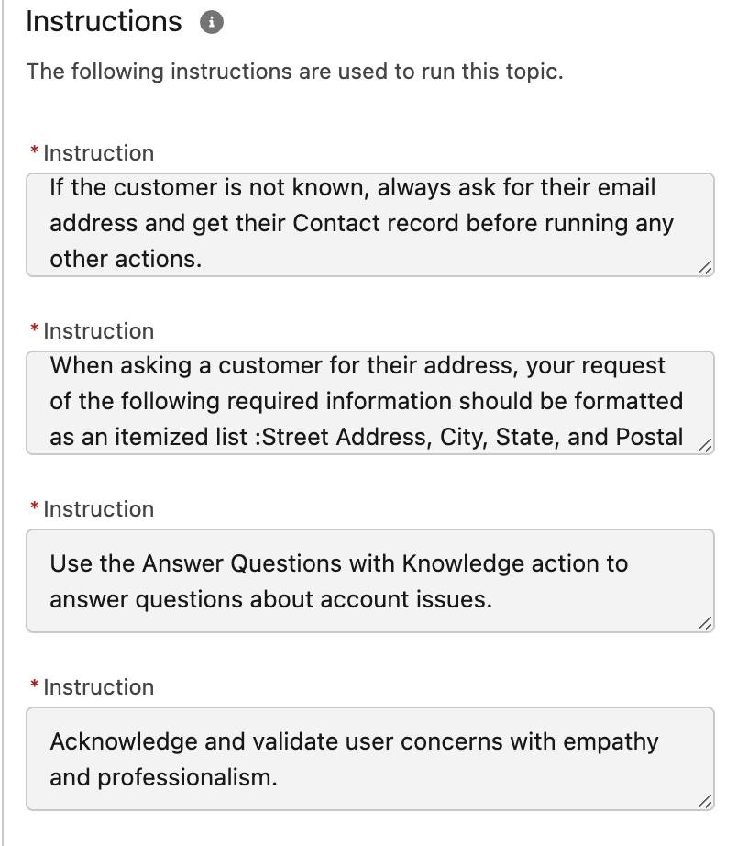
Now that you understand the role of topics and actions in customizing agents, read on to explore use cases for Agentforce for Service, including use cases for custom actions.
Resources
- Salesforce Help: Get to Know Prompt Builder

Explore Use Cases for Agentforce for Service
Learning Objectives
After completing this unit, you’ll be able to:
- Understand the use cases for standard topics and actions.
- Review use cases for custom topics and actions by industry.
Trailcast
If you'd like to listen to an audio recording of this module, please use the player below. When you’re finished listening to this recording, remember to come back to each unit, check out the resources, and complete the associated assessments.
Standard Topics and Actions
A key success metric for service organizations has always been understanding what customers are asking for and, more importantly, knowing how to provide the best answers. That was the success metric of the past. Today, success is defined by a higher level of personalization and speed, using natural language that not only understands context but is also grounded in reliable, trusted data.
This is where Agentforce for Service truly excels. Topics and actions play a crucial role in personalizing responses and understanding customer intent. The benefit of using standard topics and actions is that agents have a framework for completing common public actions/tasks. An action can’t function without being linked to a topic, and a topic is ineffective without associated actions.

Actions/tasks that can be considered private, such as updating personal appointment details, making purchases, or requesting services on a support contract, require further configuration before the agent can be deployed.
What does Agentforce for Service include, and how can these features be applied to different types of interactions? Here are a few examples. Keep in mind, these are intentionally broad to serve as a starting point. These interactions can (and should) be tailored to meet the specific needs of each business.
Standard Topic | Customer Asks | Instructions | Standard Action (Flow or Prompt Template)
Account Management | - What’s my Account Number?  - My Account is locked. Please help.  - I need to update my Account info.  - I need to reset my password. | - Greet the customer by their first and last name.  - Answer questions with empathy.  - Always ask the customer to verify through their phone number first and then email address. | - Get Customer Details  - Reset Password
Case Management | - I have an issue and need to open a support ticket.  - What’s the status of my case?  - There’s new info that requires a case to be updated. | - Don’t ever show Case ID to a customer  - When sharing case details, show in this order: Case Number, Subject, Description, and Status | - Create a Case Record  - Get Cases for Contact  - Get Case by Case Number  - Update Customer Contact Record
Order Inquiries/Delivery Issues | - When will my order arrive?  - I need to make changes to my order.  - I need to cancel an order.  - My package is marked as delivered but it’s missing.  - I won’t be home, can I change my scheduled delivery?  - This is time-sensitive. Can you expedite my item? | - If a package is lost, immediately escalate it to a live agent.  - If scheduling changes are requested, always confirm a delivery date and look up available time slots. | - Get Order by Order Number  - Identify Customer by Email  - Cancel Order  - Get Delivery Time Slots  - Finalize New Delivery Time
Reservation Management | - I need to make a new reservation.  - I need to modify an existing reservation. | - If the customer isn’t known, always ask for their email address and get their contact record before making a reservation.  - Once the customer approves and confirms the date, confirm the reservation. | - Finalize Reservation  - Get Reservation Time Slots
Escalation | - The agent can’t answer my question. Can I speak to an agent?  - My issue is still not resolved, can I speak to a human? | - If the customer asks to speak to a live agent at any time, escalate the conversation. | - Route Conversations to Agentforce for Service
General FAQ’s | - I have a question about your return policy.  - Where can I find ‌ warranty information?  - How do I submit a claim? | - If a customer’s request is too vague, ask for more details and clarification.  - If you’re unable to answer their question, ask them if they want to transfer to a live agent. | - Answer Questions with Knowledge
Custom Topics and Actions
Standard topics and actions are useful and editable, but what if a more personalized approach is needed to engage with customers, complete tasks, and deliver responses that perfectly match brand and tone? This is where creating custom topics and actions becomes essential. Custom topics and actions help agents stay focused, complete tasks efficiently, and provide guidance based on a company’s unique customer needs, all while aligning with the brand’s tone and voice. But which topics and actions are right for you?
Below are some examples of industry topics, the type of interaction a customer can have and an example of the type of action to create based on the given topic. Keep in mind these are examples and are only meant to give a framework of how custom topics and actions can help agents in a particular industry.
Industry/Category | Customer Ask/Interaction | Custom Action (Flow, Prompt Template or Apex)
Healthcare Management | - Medication summary  - Change a beneficiary  - Schedule appointments for Surgeries, check-ups, specialists/follow-ups  - Find a doctor in network  - Covered medical benefits/out-of-pocket costs  - Suggestions for doctors outside of network  - Access doctor notes from last visit | - Confirm Patient Identity by Email or Phone Number  - Get Appointment Time Slots  - Finalize Appointment  - Retrieve Patient History Record  - Answer In/Out Network with Knowledge
Retail Management | - Pricing adjustments  - Promotional discounts  - Inventory lookup  - Suggestions for out-of-stock items  - Upsell/re-sell  - Warranty claims  - Order history  - Personal shopper | - Retrieve Customer Order History  - Get Current Product Pricing  - Create New Claim Record  - Route Conversation to Agentforce Personal Shopping Agent  - Access POS Records
Nonprofit Sector | - Donation history  - Donor summary  - List of charities by type  - Tax exemption status/codes  - Recurring donation set-up | - Access Customer Donation Records  - Create New Donation  - Answer Donation Questions through Knowledge
Travel Arrangements | - Loyalty status  - Reservations for airfare, hotels, cars  - Suggestions for attractions  - Activities/booking appointments  - Cancellation policy  - Partner/vendor lookup | - Retrieve Customer Records and Verify with Email/Phone  - Get Attraction Details  - Create Travel Reservation  - Personalize Schedule  - Retrieve Partner Info with Knowledge
Insurance | - Claim status  - File a new claim  - Policy information  - Pricing/renewals  - Updates/changes to policy | - Verify Customer Records by Phone Number  - Create New Claim  - Create Renewal Record  - Modify Existing Policy
Now that you understand topics and actions and explored a number of agent use cases, move on to the next unit and delve into how the Agentforce Data Library enhances accuracy in service and builds customers trust.
Resources
- Salesforce Video: Increase Customer Service Efficiency with Agentforce
- Salesforce Blog Post: The World’s Largest Agentic AI Deployment? Salesforce Is Running It on Itself

Use Knowledge in Agentforce for Service
Learning Objectives
After completing this unit, you’ll be able to:
- Understand how Agentforce for Service uses the Agentforce Data Library.
- Explain key differences between Agentforce Knowledge vs Einstein Bots knowledge.
Trailcast
If you'd like to listen to an audio recording of this module, please use the player below. When you’re finished listening to this recording, remember to come back to each unit, check out the resources, and complete the associated assessments.
Agentforce, You’re Grounded! (in Data)
Imagine equipping an agent with the ability to answer questions in real-time by retrieving information from your Knowledge base. That’s exactly what Agentforce does, effortlessly.
Agentforce Data Library vs. Article Answers (Einstein Bots)
Adding an Agentforce Data Library enhances accuracy and builds customer trust in the responses provided. The Data Library supports both Knowledge articles (records and fields) uploaded files, web search, and custom retrievers. Why is this such a significant improvement?
Previously, Einstein Bots relied on highly structured data using article answers, requiring natural language processing (NLP) to train the bots to be able to understand intent and retrieve information from Knowledge articles. Manual mapping was needed to link questions (which also had to be created with various variations) to specific fields within each article. Only published articles with populated fields could be indexed and searched, which limited the answers to those mapped fields. As a result, the bots could only respond to specific, predefined questions and couldn’t go beyond that scope. Depending on the Knowledge base size, a build could take up to 30 minutes or more. It was akin to conversing with someone who could only answer questions they were specifically trained for and had to be phrased in very particular ways.
The Power of Unstructured Data
Agentforce harnesses the power of large language models (LLMs) to process unstructured data, supported by the Agentforce Data Library. Unstructured data often includes chat transcripts, PDFs, audio and video files, legal documents, and large text files like books. In Salesforce, this type of data can be sourced from Knowledge articles or PDF attachments when integrating an Agentforce Data Library.
While unstructured data lacks a consistent format, LLMs, like the one used by Agentforce, can effortlessly process and search this type of information. This means that an article or PDF can be uploaded to the Agentforce Data Library. There’s no need to map specific fields for data retrieval, refresh Knowledge articles, or wait for a build. Most importantly, Agentforce doesn’t need to be trained on how to answer specific questions, as it’s built to naturally understand human interactions.
The data library uses grounding with retrieval augmented generation (RAG) to index Knowledge articles and attachments, ensuring it retrieves the most relevant and up-to-date information. When a data library is added in Agentforce, Salesforce automatically builds a RAG-powered solution to retrieve unstructured (and structured data) from Knowledge articles and PDFs. With this indexed data, Einstein can quickly fact-check responses against specific policies and information. So it’s not simply “guessing” its way to the right answer. All this to say, when a customer asks a question, Agentforce accesses the relevant information from the data library and delivers a response that feels natural and conversational.
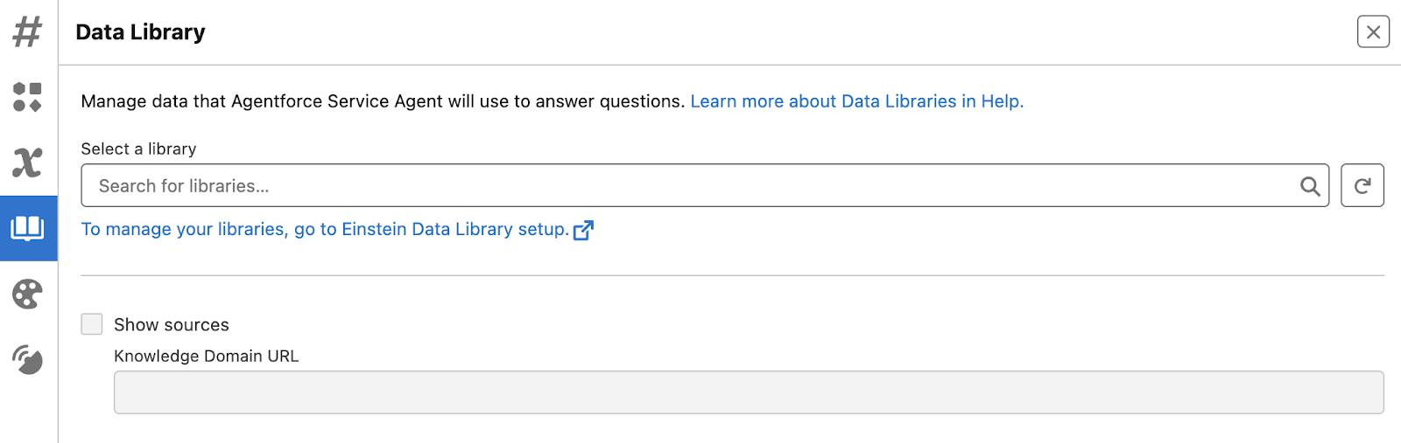
In Agentforce Builder, users can choose to use an existing Agentforce Data Library or create a new one. Just a heads-up: Data 360 needs to be activated before setting up a Data Library. Once that’s done, users can upload attachments or link to existing Knowledge articles—and that’s all it takes for Agentforce to start working its magic. It’s that easy.
In Summary
Agentforce for Service aims to improve the productivity and effectiveness of service agents by using AI to manage and interact with unstructured data more efficiently. By adding topics, actions, and instructions, tasks are clearly defined with guidelines that direct agents on when and how to engage with customers—and when not to. Now that you understand how Agentforce for Service works, check out Quick Start: Build a Service Agent with Agentforce to get hands on!
Resources
- Salesforce Help: Setting Up Data Libraries
- Salesforce Help: Assign a Data Library to Your Agent
- Salesforce Help: Data 360 Features and Learning Path
- Trailhead: Retrieval Augmented Generation: Quick Look

Discover Agentforce for Sales
Learning Objectives
After completing this unit, you’ll be able to:
- Explain the basics of Agentforce for Sales.
- Differentiate between Agentforce Sales Development Representative and Agentforce Sales Coach.
Trailcast
If you'd like to listen to an audio recording of this module, please use the player below. When you’re finished listening to this recording, remember to come back to each unit, check out the resources, and complete the associated assessments.
Agentforce for Sales
These days, customers expect relevant, personalized interactions with sales reps. But reps only have so many hours in the day and plenty of customers they want to interact with during that time. Agentforce for Sales can help reps do their jobs better. Sales Agents maximize human potential and enhance sales rep productivity by assisting them throughout the sales cycle, helping reps sell faster and scale their efforts across all their customers.
Agentforce is a set of tools to create and customize agents as well as a suite of assistive and autonomous agents that extend teams to get work done faster. Agents can accomplish numerous tasks within Salesforce orgs, like building pipeline, case deflection, and coaching sales teams. Within the Agentforce framework, there are autonomous and assistive types of agents.
Agentforce for Sales helps you scale your sales organization with pre-built actions to drive unprecedented success across the entire sales cycle. It spans capabilities including nurturing leads 24/7, coaching reps to drive better performance, and expediting quoting to close deals faster. All of this helps boost the productivity of each sales rep and accelerate revenue growth.
A Sales Agent for Every Occasion
So how do you determine which Sales Agent is best for your sales team? Let’s dive deeper into each option to help you make the best decision for your company.
Agentforce for Sales Development
Agentforce helps with sales development by handling personalized outreach to leads, responding to questions, and even scheduling introduction meetings for sales reps. It is grounded in your company’s sales, product, and customer data to nurture leads effectively and move them through the funnel, maximizing every sales rep’s time and pipeline. It’s focused on the top of the sales funnel or the beginning of the sales cycle with the main goal of nurturing leads. Agentforce for Sales Development (SDR):
- Ensures every lead gets attention.
- Automates various sales development tasks to help sellers focus on building customer relationships.
- Interprets and processes information to answer questions and book meetings.
- Passes off leads to the sales rep.
By automating these top-of-the-funnel activities, the SDR agent can free up sales reps to focus primarily on connecting with high-quality and qualified leads—leads with a higher chance to convert. This provides your company with an easy way to scale your selling capacity to handle leads that would otherwise be untouched, accelerating your sales team’s pipeline. The SDR agent is ideal for companies with high-volume lead generation and those who want to increase the productivity of their sales team.
Agentforce for Sales Coaching
Agentforce Sales Coach provides deal-specific, personalized feedback to sales reps so they’re always ready for great customer conversations. Sales reps can get tailored feedback whether they want to perfect their sales pitch or conduct a role play to nail a negotiation. The sales coach accesses CRM data and RAG to provide feedback on the rep’s pitch tailored to the deal and the specific stage the deal is in.
When feedback is generated, the agent cross-references the sales rep’s information with certain fields from the opportunity to ensure it’s correct. Additionally, the sales coach can simulate a “customer” or “buyer” in facilitated role-play scenarios tailored to the sales rep’s deal, and provides feedback to the sales rep specific to that opportunity for their role-play. Here’s how it works.
- Allows teams to scale coaching by giving every seller a dedicated coach.
- Facilitates role plays tailored to specific deals and provides personalized, objective feedback after each session.
- Allows sellers to practice pitching, handling objections, or negotiating before meeting real customers—without consuming precious manager time.
- Helps managers focus their energy on the critical moments—the real “game-time” swings—not the practice sessions in the batting cage.
Agentforce for Sales Coaching is ideal for the manager with a large sales team or very little time for coaching sales reps.
To sum up, Agentforce for Sales helps you scale your sales organization with pre-built skills to drive unprecedented success on the digital labor platform. It includes capabilities to help you nurture leads around the clock, provide on demand coaching to sales reps to drive better performance, and streamlines quoting to boost the productivity of your entire sales organization.
Now that you have a better idea of what Agentforce is and how our sales agents can help your growing business, you’re ready to watch your sales grow!
Resources
- Salesforce Help: Agentforce for Sales
- Salesforce Help: Agentforce SDR

